needed. Thank you for your time and effort.
Newsletter
GRANGE MEDICAL CENTRE/OAKLANE SURGERY
PATIENT NEWSLETTER

E – Consult Service

The practice is taking E-consultations. E consult provides an online portal where patients can self check their symptoms and receive medical advice. Patients electing to E-Consult with their GP simply fill out an online form.

You can ask for help with a specific problem or condition, ask for general advice if you are not sure what your symptoms mean or request for administrative help for things like sick notes etc.
You will be asked the same questions a doctor would ask in a face to face appointment.
You can receive advice and treatment by the end of the next working day, you may not have to even come to the surgery.

Summer 2020 Issue

Time Changes
from 1st of June acute messages will be taken from:
9AM - 10.30AM and 12Noon - 1.30PM
Please do not make any acute requests after this time.

From 1st of June phone lines will be open from:
8AM - 6PM Monday - Friday

Coronovirus
COVID-19 is a new illness that can affect your lungs and airways. It's caused by a virus called coronavirus.
Please keep social distancing at all times.
COVID-19 has been updated to include loss of or change in smell or taste. It is now:
New continuous cough OR fever OR loss of/ change in smell or taste
Everyone, including health and social care workers, should self-isolate if they develop a new continuous cough or fever or loss of/ change in smell or taste.
The individual/s household should also self-isolate for 14 days as per the current guidelines and the individual should stay at home for 7 days, or longer if they still have symptoms other than cough or loss of sense
of smell or taste.
If you think you might have coronavirus or you've been in close contact with someone who has it:
- stay at home and avoid close contact with other people
- do not go to a GP surgery, pharmacy or hospital
- use the NHS 111 online coronavirus service to find out what to do next
The 111 coronavirus service will tell you if you need to continue to stay at home (self-isolate) or if you need medical help.

Please remember to enter your number plate when parking in the car park, otherwise you will be fined.

Extended Access

The surgery will be open for extended access on Monday till 7.30pm. These appointments are for people who are unable to attend during the day. We will no longer have the extended access on Friday as the GP, Nurse and HCA are doing extended access on Monday.

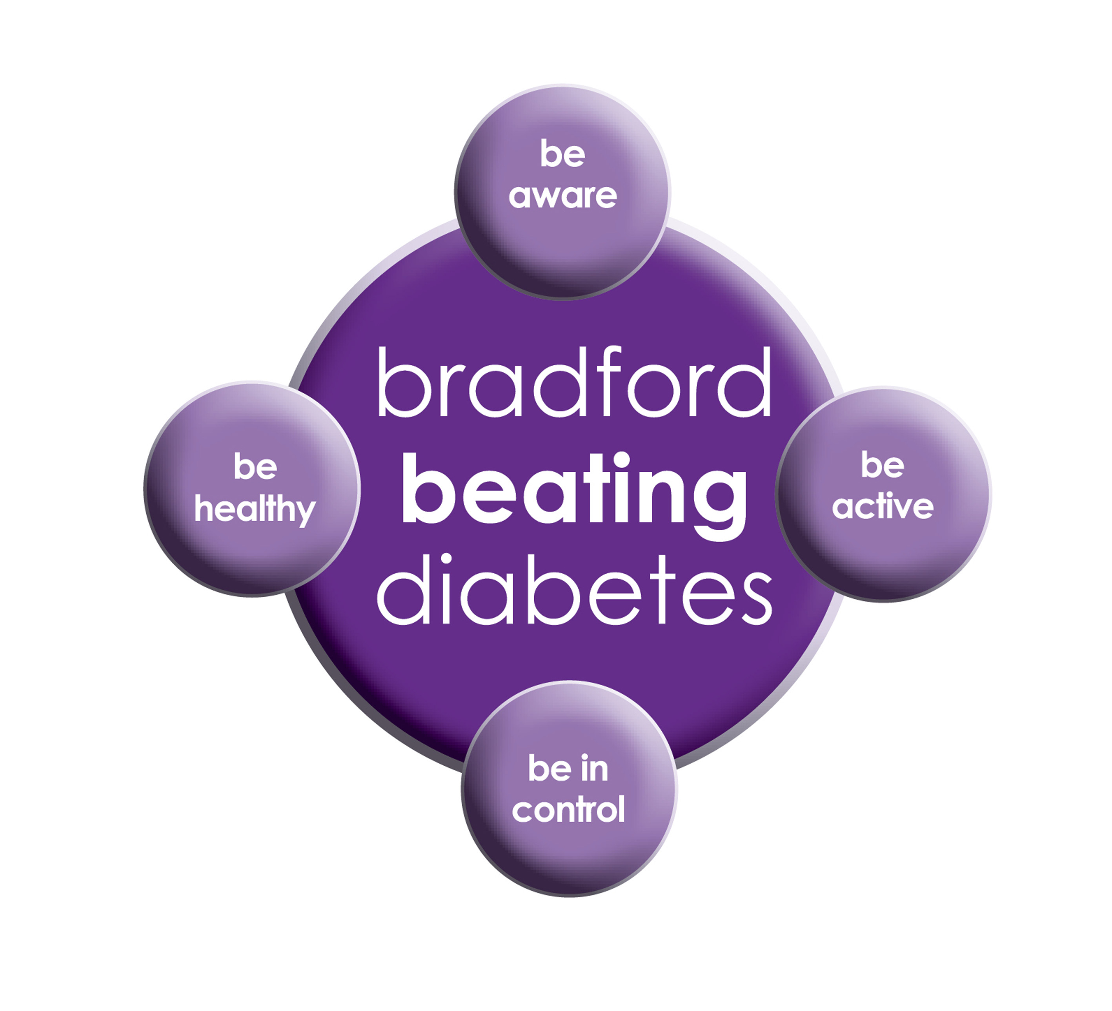
BRADFORD Beating Diabetes campaign is celebrating the success of its champions and patients who have been on the intensive lifestyle change programme.

In the 16 months since the campaign started, there have been about 1,000 newly-diagnosed patients in the city and a further 10,000 patients have received a brief lifestyle intervention from their family doctor.

The practice is inviting all adults aged over 25 (if they are from South Asian and certain other BME groups) or if they are aged over 40 (and white) and any others with conditions known to increase their risk of developing diabetes.
Some people are more at risk of developing diabetes than others:

- Those that have a family history of diabetes
- People who are overweight or have a large waist size
- People who are not physically active
- People who are south Asian or African Caribbean

Please book an appointment if you think you are at risk of being diabetic.

Screening Programmes

Bowel cancer screening
Bowel cancer screening aims to check for bowel cancer or abnormalities that could lead to bowel cancer. The screening tests include:
- testing for blood in your poo (stools)
- looking inside your bowel using a scope (bowel scope)
Cervical Screening
Screening means testing for early signs of an illness before you have symptoms. Cervical screening picks up changes in the cells covering the cervix (the neck of your womb) that could develop into cancer in the future. It isn’t a test for cancer. It’s a test for abnormal pre-cancerous changes in these cells, which can then be treated to stop cancer developing. Cervical screening is highly effective at preventing cervical cancer. It saves around 4,500 lives every year in England alone.
Breast Screening
Women between the ages of 50 and 70 are now routinely invited for free screening every three years. Patients who have DNA’d there appointments can still get the screening done. Please ring the department on
Phone: 01274 365521

A&E and 999 are very busy services. They are used for emergencies like heart attacks, strokes and broken bones. Please use another service when it isn't an emergency so that A&E can be used by the people who need it most.

If you follow this advice and choose the right place to go for NHS treatment, this will ensure that you get the right care, as soon as possible.

Did Not Attend Policy:

When a patient fails to attend an appointment with a healthcare professional at the surgery a note of the date and time is made in their record. They are now sent a letter, If a patient fails to attend 2 appointments with a healthcare professional within a 3 month period, the patient will then receive another letter reminding them of the importance of cancelling an unwanted appointment.

If following this, the patient fails to attend another appointment, the Practice Manager will write to the patient informing them that they are at risk of being taken of the list, if the patient isn’t able to provide a valid explanation.

In the last month we have had a total of 186 patients DNA(did not attend) appointments. These appointments could have been used by patients who required medical attention. If you do need an appointment please remember to cancel the appointment, please give at least 24 hours’ notice.

To cancel appointments please call:
01274 957908 (Grange Medical)
01274 957909 (Oaklane surgery)

M ED IPARKING CONDITIONS
GRANGE MEDICAL CENTRE PATIENT PARKING ONLY
PATIENTS/VISITORS MUST OBTAIN A PARKING PERMIT
AT RECEPTION
Or you will be fined

Dates our Surgeries are closed:

Please note that the surgeries will be CLOSED on:
Monday 25th May 2020 Spring bank holiday
- Monday, 31st August 2020
Please contact Out Of Hours for any emergencies during those times on NHS 111

FREE Text Reminders for your Appointments

Sign up NOW and give consent so that you can receive your FREE text reminder message. Consent Forms are available from Reception.
Please make sure we have an up to date mobile number.

Would you like to sign up for newsletters by email? If so, please let the Reception have your email address.

REPEAT PRESCRIPTIONS

This is a kind reminder for the patients regarding repeat prescriptions. GP practices can no longer accept repeat prescription requests from pharmacies.
You (or your carer, nominated family member/friend) must order your repeat prescription from your GP practice. Due to COV19 you can ring the surgery line, or put your repeat requests in the black box near the door. We would suggest you get online access if you havent already got this to order repeat medication online.

PATIENT PARTICIPATION

Here at Grange Medical Centre and at Oaklane Surgery we are always keen to hear what you think about the level of care and services provided.

You can get involved in the work of the practice by: Joining our Patient Participation Group. Joining our Virtual Group and leaving your contact details with reception.

Contacting us via our practice web site at www.drirshadkhanandpartners.co.uk

Our Patient Participation Group meetings are held quarterly at Grange Medical Centre.

Any Queries contact Mrs Shamraz Akhtar our PPG Lead or email Shamraz.Akhtar@bradford.nhs.uk
Tel:01274 957908

Community Centres

The local Community centres have events and different classes available for patients and advice. The classes involve Healthy lifestyle classes, Exercise classes, Healthy cooking and eating, sewing classes, swimming classes. They are very effective and low cost classes. If you are on any benefits they may be free.

Grange Interlink contact:

Tel: 01274 726612
Summerville Rd, Bradford BD7 1PX.
Opening Times: Mon- Fri 9am till 4pm

Khidmet Centre contact :

Tel: 01274 521792
36 Spencer Rd, Bradford BD7 2EU
Opening Times: Mon- Fri 9am till 5pm

Girlington Community Centre:

Tel: 01274 542454
Girlington Rd, Bradford BD8 9NN
Opening Hours: · 9am–5pm

