*needed. Thank you for your time and effort.*

**Newsletter**

**GRANGE MEDICAL CENTRE/OAKLANE SURGERY**

**PATIENT NEWSLETTER**

**Summer 2021 Issue**

**Carers Week i**s an annual campaign to raise awareness of caring, highlight the challenges unpaid carers face and recognise the contribution they make to families and communities throughout the UK. It also helps people who don't think of themselves as having caring responsibilities to identify as carers and access much-needed support.

This year we are coming together to **Make Caring Visible and Valued**.

**Please see attached poster for further information.**

**First of all, welcome to this Newsletter at a time of Covid 19.**

Covid-19 has had an impact worldwide. We would like to thank you for helping the practice. As you will know the practice has moved a lot of appointments from being face-to-face to being remote e.g. phone or video consultations and e-consultations (eConsult), due to covid. *However we do continue to offer F2F appointments for clinicians where possible after triaging the appointments. We are working on a same day triage service for GP’s. Nurse appointments can be pre-booked in advance by contacting reception.*

*Please make sure if you are due your diabetes*

*Review or Smear Test please contact the surgery.*

**If you think you might have coronavirus or you've been in close contact with someone who has it:**

* stay at home and avoid close contact with other people
* do not go to a GP surgery, pharmacy or hospital
* use the NHS 111 online coronavirus service to find out what to do next

**The 111 coronavirus service will tell you if you need to continue to stay at home (self-isolate) or if you need medical help.**

Covid vaccines

We have been booking patients for the covid vaccine clinic. Please book your covid vaccine. If you have had your 1st vaccine please ring in and book for the 2nd dose when you are due. If you are aged 40 and over, please book for the Astrazeneca vaccine and if you are aged 40 and under you can be booked for the Pfizer vaccine.

**Please remember to enter your number plate when parking in the car park, otherwise you will be fined.**

**Extended Access**

The surgery will be open for extended access on Monday till 7.30pm. These appointments are for people who are unable to attend during the day. We will no longer have the extended access on Friday as the GP, Nurse and HCA are doing extended access on Monday.

**Screening Programmes**

**Bowel cancer screening**

Bowel cancer screening aims to check for bowel cancer or abnormalities that could lead to bowel cancer. The screening tests include:

* testing for blood in your poo (stools)
* looking inside your bowel using a scope (bowel scope)

**Cervical Screening**

Screening means testing for early signs of an illness before you have symptoms. Cervical screening picks up changes in the cells covering the cervix (the neck of your womb) that could develop into cancer in the future. It isn’t a test for cancer. It’s a test for abnormal pre-cancerous changes in these cells, which can then be treated to stop cancer developing. Cervical screening is highly effective at preventing cervical cancer. It saves around 4,500 lives every year in England alone.

If you are due smear tests please ring the surgery and book yourself in.

**Breast Screening**

Women between the ages of 50 and 70 are now routinely invited for free screening every three years. Patients who have DNA’d there appointments can still get the screening done. Please ring the department on

[**Phone**](https://www.google.co.uk/search?q=pennine+breast+screening+service+phone&ludocid=4991663712128620368&sa=X&ved=2ahUKEwiY2J3J-ZvlAhWGN8AKHY7pBR8Q6BMwE3oECAsQKw)**:** 01274 365521

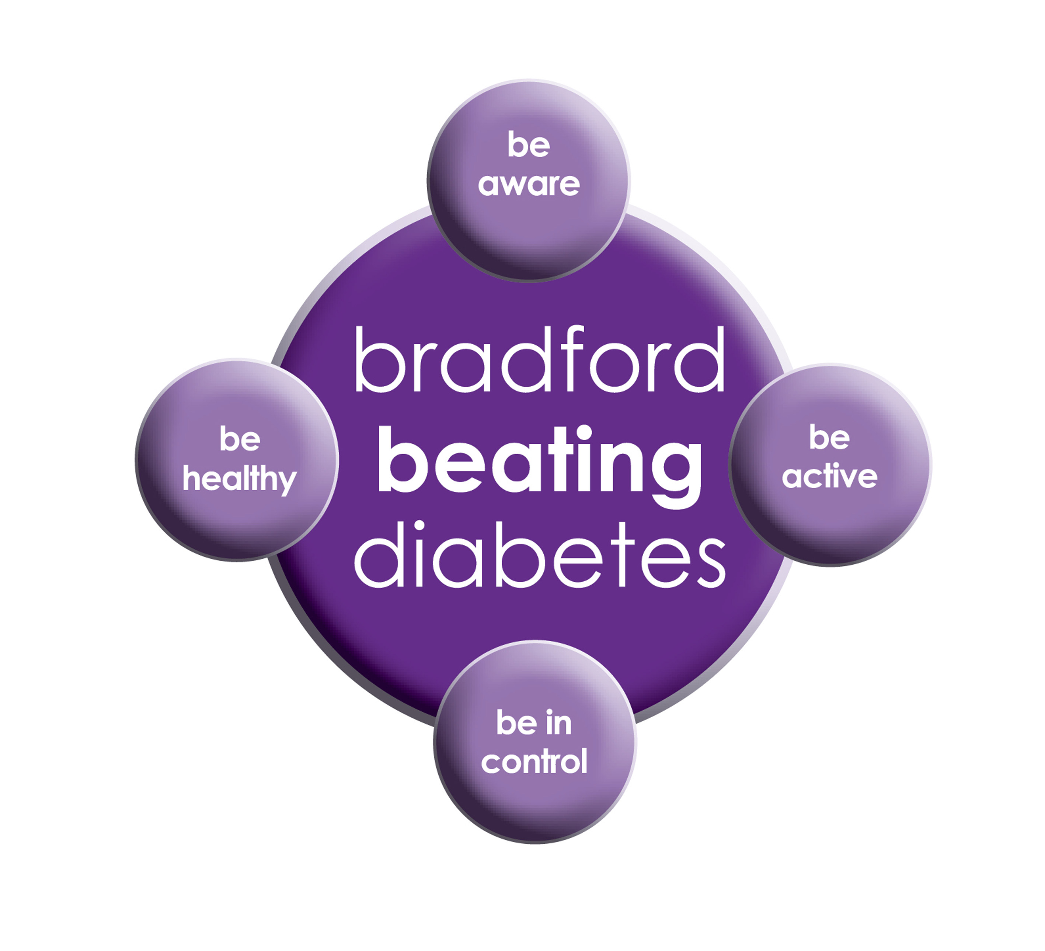

BRADFORD Beating Diabetes campaign is celebrating the success of its champions and patients who have been on the intensive lifestyle change programme.

In the 16 months since the campaign started, there have been about 1,000 newly-diagnosed patients in the city and a further 10,000 patients have received a brief lifestyle intervention from their family doctor.

The practice is inviting all adults aged over 25 (if they are from South Asian and certain other BME groups) or if they are aged over 40 (and white) and any others with conditions known to increase their risk of developing diabetes.

Some people are more at risk of developing diabetes than others:

- Those that have a family history of diabetes

- People who are overweight or have a large waist size

- People who are not physically active

- People who are south Asian or African Caribbean

**Please book an appointment if you think you are at risk of being diabetic.**

Due to the panademic there have been a lot of patients who have felt isolated, stressed or depressed. Here are some useful numbers for organisations that can help.

**SANE Line provide** Emotional support 0300 304 7000 (daily, 4.30pm to 10.30pm)

**Mind in Bradford Isolation support**

01274 730815

**Guide line**

Stress ,depressed

01274 594594

**My Well being college**

City Improving Access to Psychological Therapies (IAPT) Team Tel: 01274 322644

**First response team (mental health crisis)**

01274 221181

**First response team (Mental health crisis )**

01274 221181

**Dates our Surgeries are closed:**

**Please note that the surgeries will be CLOSED on:**

**Monday 31th May 2021**

* **Monday, 30st August 2021**

**Please contact Out Of Hours for any emergencies during those times on NHS 111**

**Did Not Attend Policy:**

When a patient fails to attend an appointment *with a healthcare professional at the surgery a note of the date and time is made in their record. They are now sent a letter, If a patient fails to attend 2 appointments with a healthcare professional within a 3 month period, the patient will then receive another letter reminding them of the importance of cancelling an unwanted appointment.*

*If following this, the patient fails to attend another appointment, the Practice Manager will write to the patient informing them that they are at risk of being taken of the list, if the patient isn’t able to provide a valid explanation.*

**To cancel appointments please call:**

**01274 957908 (Grange Medical)**

**01274 957909 (Oaklane surgery)**

**A&E and 999 are very busy services. They are used for emergencies like heart attacks, strokes and broken bones. Please use another service when it isn't an emergency so that A&E can be used by the people who need it most.**

**If you follow this advice and choose the right place to go for NHS treatment, this will ensure that you get the right care, as soon as possible.**

**FREE Text Reminders for your Appointments**

**Sign up NOW and give consent so that you can receive your FREE text reminder message. Consent Forms are available from Reception.**

**Please make sure we have an up to date mobile number.**

**Would you like to sign up for newsletters by email? If so, please let the Reception have your email address.**

**REPEAT PRESCRIPTIONS**

**This is a kind reminder for the patients regarding repeat prescriptions. GP practices can no longer accept repeat prescription requests from pharmacies.**

**You (or your carer, nominated family member/friend) must order your repeat prescription from your GP practice. Due to COV19 you can ring the surgery line, or put your repeat requests in the black box near the door. We would suggest you get online access if you havent already got this to order repeat medication online.**

**Over The Counter Medication**

Your GP will not generally give you a prescription for over the counter medicines for a range of short-term, minor health concerns. Instead, over the counter medicines are available to buy in a pharmacy or supermarket in your local community. The team of qualified healthcare professionals at your local pharmacy can offer clinical advice to manage minor health concerns safely and effectively.

[](http://www.onemedicare-northstreet.co.uk/Images/CMS/Media/62-PP.jpg)

**PATIENT PARTICIPATION**

**Here at Grange Medical Centre and at Oaklane Surgery we are always keen to hear what you think about the level of care and services provided.**

**You can get involved in the work of the practice by: Joining our Patient Participation Group. Joining our Virtual Group and leaving your contact details with reception.**

**Contacting us via our practice web site at www.drirshadkhanandpartners.co.uk**

**Our Patient Participation Group meetings are held quarterly at Grange Medical Centre.**

**Any Queries contact Mrs Shamraz Akhtar our PPG Lead or email** [Shamraz.Akhtar@bradford.nhs.uk](mailto:Shamraz.Akhtar@bradford.nhs.uk)

**Tel:01274 957908**

**OPT-OUT**

**Type 1 Opt-out: If you don’t want your identifiable patient data to be shared for purposes except for your own care, you can opt-out by registering a Type 1 Opt-out. You can download the form from our practice website:**

[**https://www.drsyedzaidiandassociates.nhs.uk/**](https://www.drsyedzaidiandassociates.nhs.uk/) **and return it to the surgery before the deadline of June 23rd 2021.  You can also submit form online from our practice website.**

**DO YOU CARE FOR A FRIEND OR RELATIVE?** DO YOU LIVE IN

CRAVEN, AIREDALE, BRADFORD, HARROGATE OR WHARFEDALE?

# \\tcr-server\carers\Publicity\LOGOS May 2011\New Carers Logo 2011 with strap (RGB).JPG

# Join us online for Wellbeing sessions

|  |  |  |
| --- | --- | --- |
| **Tuesday 25th May** | **10am -11.00am** | **Crafts** |
| **Tuesday 8th June** | **10am -11.30am** | **Tea party, Carers Week** |
| **Thursday 10th June** | **1pm – 2.30pm** | **Tea Party, Carers Week** |
| **Thursday 27th July** | **10am -11.30am** | **Soup Session** |
| **Tuesday 31st August** | **10am -12:00pm** | **Self Care** |
| **Tuesday 28th Sept** | **10am -11.00am** | **Crafts** |
| **Tuesday 26th October** | **10am -11.30am** | **Soup Session** |
| **Friday 26th November** | **10am -12:00pm** | **Self care** |
| **Tuesday 14th December** | **10am – 11.00am** | **Coping strategies** |

Practical tools will be made available to attendees

Carers and cared for welcome

**Spaces are limited, to book a place and get the link call - 01274 449660 (we can help you get online!)**

