*needed. Thank you for your time and effort.*

**Newsletter**

**GRANGE MEDICAL CENTRE/OAKLANE SURGERY**

**PATIENT NEWSLETTER**

**Autumn/ Winter 2019 Issue**

# *Winter Self Care Advice*

Many of us will have a cold, sore throat or other minor illness at some point during the winter and some of us will have flu. The most common winter illnesses will usually get better without the need to see a doctor.

Here are some tips to help you keep well and self-care through the winter months:

**1. Treat yourself at home**

Colds, flu and most sore throats do not need antibiotics and you can treat your symptoms at home. Make sure you get lots of rest, drink plenty of water and take pain relievers, such as paracetamol or ibuprofen, if you need them.

**2. Order repeat prescriptions and book your flu jab in good time**

If you take regular medication make sure you order your repeat prescriptions in good time. If you're eligible for a flu jab.

**3. Speak to your pharmacist**

Your local pharmacy can recognise many common health complaints. They can give advice or, where appropriate, medicines to help you manage the symptoms.  If your problem is more serious or you need medical advice, your pharmacist will advise you to contact your GP.

You can also ask your pharmacist what over the counter remedies to keep in your medicine cabinet at home to help get you and your family through the winter months.

**4. Check online for information and advice**

There is lots of information on the NHS websites about how to keep well, check your symptoms or use self-care to stay healthy and treat common winter illnesses such as colds, sore throats and flu.

[Visit NHS England](https://www.nhs.uk/live-well/)

You can also get advice on how to self care, including leaflets to help you manage the most common ailments from the Self Care Forum website.

## ****What is flu?****

Flu is an acute viral infection of the respiratory tract, usually characterised by a fever, chills, headache, aching muscles, joint pain and fatigue. It is a highly infectious virus different to the common cold, and spreads rapidly in closed communities and even people with mild or no symptoms can infect others.

Flu kills an average of 8,000 people every year, and it can be particularly serious in older adults, very young children, and people with underlying health conditions.

## ****Why get the vaccine and who is eligible?****

The flu vaccine remains the best defence we have against flu and protects those people who are most vulnerable.

Certain groups of people are at higher risk from flu, including adults aged 65 and over, those with underlying health conditions, pregnant women, and frontline health and social care workers.

In 2019/20, the flu vaccination will be offered to:

* *Those aged 65 years and over, those aged 6 months to * Under 65 years in clinical risk groups.
* * Pregnant women.
* * Those living in a residential or nursing home.
* * The main carer of an older or disabled person.
* * Children aged 2-3 (on 31 August 2019) and all primary school aged children.

Employers of frontline health and social care workers also have a responsibility to ensure their staff can get the free vaccine.

## ****How can I protect myself, my family and those around me from the flu?****

## Flu is very infectious and the virus can live on hands and hard surfaces for up to 24 hours. This is why it is important to “Catch it, Bin it, Kill it” - “Catch” any sneezes in a tissue, “If you are unwell, look after yourself, drink plenty of fluids and stay at home so you don’t spread flu to others.

**The vaccine remains the best defence we have to protect against the spread of flu and we encourage everyone eligible to get it each year.**

**Please remember to enter your number plate when parking in the car park, otherwise you will be fined.**

**Extended Access**

The surgery will be open for extended access on Monday till 7.30pm. These appointments are for people who are unable to attend during the day. We will no longer have the extended access on Friday as the GP, Nurse and HCA are doing extended access on Monday.

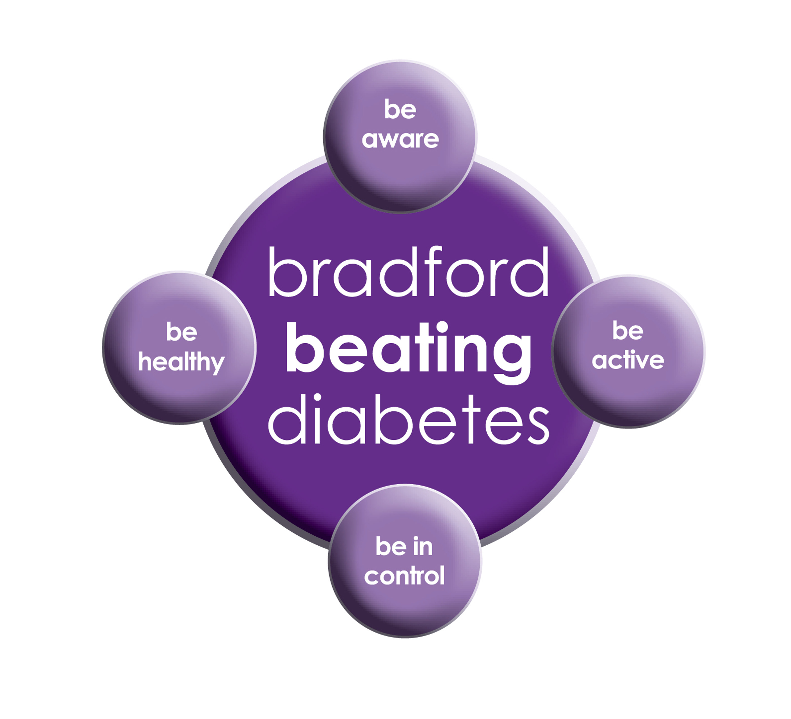

BRADFORD Beating Diabetes campaign is celebrating the success of its champions and patients who have been on the intensive lifestyle change programme.

In the 16 months since the campaign started, there have been about 1,000 newly-diagnosed patients in the city and a further 10,000 patients have received a brief lifestyle intervention from their family doctor.

The practice is inviting all adults aged over 25 (if they are from South Asian and certain other BME groups) or if they are aged over 40 (and white) and any others with conditions known to increase their risk of developing diabetes.

Some people are more at risk of developing diabetes than others:

- Those that have a family history of diabetes

- People who are overweight or have a large waist size

- People who are not physically active

- People who are south Asian or African Caribbean

**Please book an appointment if you think you are at risk of being diabetic.**

**Breast Screening**

Women between the ages of 50 and 70 are now routinely invited for free **screening** every three years. Patients who have DNA’d there appointments can still get the screening done. Please ring the department on

[**Phone**](https://www.google.co.uk/search?q=pennine+breast+screening+service+phone&ludocid=4991663712128620368&sa=X&ved=2ahUKEwiY2J3J-ZvlAhWGN8AKHY7pBR8Q6BMwE3oECAsQKw)**: 01274 365521**

**Dates our Surgeries are closed:**

**Please note that the surgeries will be CLOSED on:**

* **Wednesday, 25 December 2019 Christmas Day.**
* **Thursday, 26 December 2019 Boxing Day.**
* **Wednesday 1st January 2020 New Years Day**

**Please contact Out Of Hours for any emergencies during those times on NHS 111**

**Did Not Attend Policy:**

When a patient fails to attend an appointment *with a healthcare professional at the surgery a note of the date and time is made in their record. They are now sent a letter, If a patient fails to attend 2 appointments with a healthcare professional within a 3 month period, the patient will then receive another letter reminding them of the importance of cancelling an unwanted appointment.*

*If following this, the patient fails to attend another appointment, the Practice Manager will write to the patient informing them that they are at risk of being taken of the list, if the patient isn’t able to provide a valid explanation.*

*In the last month we have had a total of* ***186*** *patients DNA(did not attend) appointments. These appointments could have been used by patients who required medical attention. If you do need an appointment please remember to cancel the appointment,* ***please give at least 24 hours’ notice****.*

**To cancel appointments please call:**

**01274 957908 (Grange Medical)**

**01274 957909 (Oaklane surgery)**

**M ED IPARKING CONDITIONS**

GRANGE MEDICAL CENTRE PATIENT PARKING ONLY

PATIENTS/VISITORS MUST OBTAIN A PARKING PERMIT

AT RECEPTION

**Or you will be fined**

**E – Consult Service**

***The practice is taking E-consultations. E consult provides an online portal where patients can self check their symptoms and receive medical advice. Patients electing to E-Consult with their GP simply fill out an online form.***

***You can ask for help with a specific problem or condition, ask for general advice if you are not sure what your symptoms mean or request for administrative help for things like sick notes etc.***

***You will be asked the same questions a doctor would ask in a face to face appointment.***

***You can receive advice and treatment by the end of the next working day, you may not have to even come to the surgery.***

**REPEAT PRESCRIPTIONS**

This is a kind reminder for the patients regarding repeat prescriptions. GP practices can no longer accept repeat prescription requests from pharmacies.

You (or your carer, nominated family member/friend) must order your repeat prescription from your GP practice. We are having patients ringing the surgery line, this causes delay answering **urgent calls** please put the request in the red box.

**FREE Text Reminders for your Appointments**

**Sign up NOW and give consent so that you can receive your FREE text reminder message. Consent Forms are available from Reception.**

**Please make sure we have an up to date mobile number.**

**Would you like to sign up for newsletters by email? If so, please let the Reception have your email address.**

**Community Centres**

***The local Community centres have events and different classes available for patients and advice. The classes involve Healthy lifestyle classes, Exercise classes, Healthy cooking and eating, sewing classes, swimming classes. They are very effective and low cost classes. If you are on any benefits they may be free.***

***Grange Interlink contact:***

***Tel: 01274 726612***

*Summerville Rd, Bradford BD7 1PX.*

*Opening Times: Mon- Fri 9am till 4pm*

***Khidmet Centre contact :***

***Tel: 01274 521792***

*36 Spencer Rd, Bradford BD7 2EU*

*Opening Times: Mon- Fri 9am till 5pm*

**Girlington Community Centre**:

**Tel: 01274 542454**

Girlington Rd, Bradford BD8 9NN

Opening [Hours](https://www.google.co.uk/search?q=girlington+community+centre+hours&sa=X&ved=0ahUKEwi9_qTjm4LYAhVIOJoKHcM0Bw4Q6BMIlwEwEQ): · [9am–5pm](javascript:void(0))

[](http://www.onemedicare-northstreet.co.uk/Images/CMS/Media/62-PP.jpg)

**PATIENT PARTICIPATION**

**Here at Grange Medical Centre and at Oaklane Surgery we are always keen to hear what you think about the level of care and services provided.**

**You can get involved in the work of the practice by: Joining our Patient Participation Group. Joining our Virtual Group and leaving your contact details with reception.**

**Contacting us via our practice web site at www.drirshadkhanandpartners.co.uk**

**Our Patient Participation Group meetings are held quarterly at Grange Medical Centre.**

**Any Queries contact Mrs Shamraz Akhtar our PPG Lead or email** [Shamraz.Akhtar@bradford.nhs.uk](mailto:Shamraz.Akhtar@bradford.nhs.uk)

**Tel:01274 957908**