**NEWSLETTER Spring/Summer 2024 Issue**

**Dear Patients** 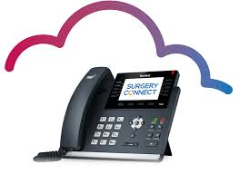

We would like to inform you that we have new **telephone lines** set up at both practices.   
The new system is designed to make patients access easier and get them the medical attention and advice they need as effectively as possible. We had reviews from patients saying that it can be frustrating contacting their busy GP practice. These lines are used to make this process as simple, fast, and as secure as possible.

There is a facility for call backs for patients is the call ques exceed the practice’s threshold. The call back holds the patient’s place in the queue after they have called in and selected the call back option. They receive a callback from the practice instead of waiting on the line, saving time.

There are also dedicated options for patients like finding out about their blood test or repeat prescriptions. You don’t have to wait around at busy appointment times.

**Updated Practice Website**

**We have also updated the practice website according to the NHS guidelines. The new website is user friendly for everyone. It contains pictures for easy access and easy use via the mobile phones as well.**

**Our opening hours are Monday to Friday 8am - 6:00pm. Any urgent problems outside of these hours need to be directed to NHS 111 who can give advice, arrange a home visit or book an appointment out of hours.**

**Covid Vaccines**

**We also plan to administer covid vaccinations alongside the flu vaccinations. If you are due for your covid vaccine, please query with the practice. Currently Covid vaccinations are booked with PCN 6 @ Woodroyd Centre**



**Please remember to enter your number plate when parking in the car park, otherwise you will be fined.**

**Extended Access**

The surgery will be open for extended access on Monday till 7.30pm. These appointments are for people who are unable to attend during the day. We will no longer have the extended access on Friday as the GP, Nurse and HCA are doing extended access on Monday.

***PATCHES Services***

You can also leave a message online via PATCHES (this can be accessed via the practice website). The Message will be triaged within 72 hours. This is a service that will help people that are working late and are unable to call the Practice during core hours. A lot of patients find this service very helpful.

***Appointment System***

Practice continues to offer Face to Face and telephone appointments after messages are triaged by clinicians. The message line opens at 8.45am till 9.45am and 11.45am till 12.45pm. If there is an urgent issue the clinician on call will give the appropriate advice.

**Enhanced Access**

Enhanced Access All GP Primary Care Networks offer some appointments after 6:30pm and on Saturdays. These are for all members of our team (HCAs, nurses, blood tests, smear tests physiotherapists, and doctors) by ringing the surgery.

**Importance of screening services**

**Cervical Screening**

Screening means testing for early signs of an illness before you have symptoms. Cervical screening picks up changes in the cells covering the cervix (the neck of your womb) that could develop into cancer in the future. It isn’t a test for cancer. It’s a test for abnormal pre-cancerous changes in these cells, which can then be treated to stop cancer developing. Cervical screening is highly effective at preventing cervical cancer. It saves around 4,500 lives every year in England alone.

**Breast Screening**

Women between the ages of 50 and 70 are now routinely invited for free screening every three years. Patients who have **missed** their appointments can still get the screening done. Please ring the department on

[**Phone**](https://www.google.co.uk/search?q=pennine+breast+screening+service+phone&ludocid=4991663712128620368&sa=X&ved=2ahUKEwiY2J3J-ZvlAhWGN8AKHY7pBR8Q6BMwE3oECAsQKw)**: 01274 365521**

**Bowel cancer screening**

Bowel cancer screening aims to check for bowel cancer or abnormalities that could lead to bowel cancer. The screening tests include:

* testing for blood in your poo (stools)
* looking inside your bowel using a scope (bowel scope)

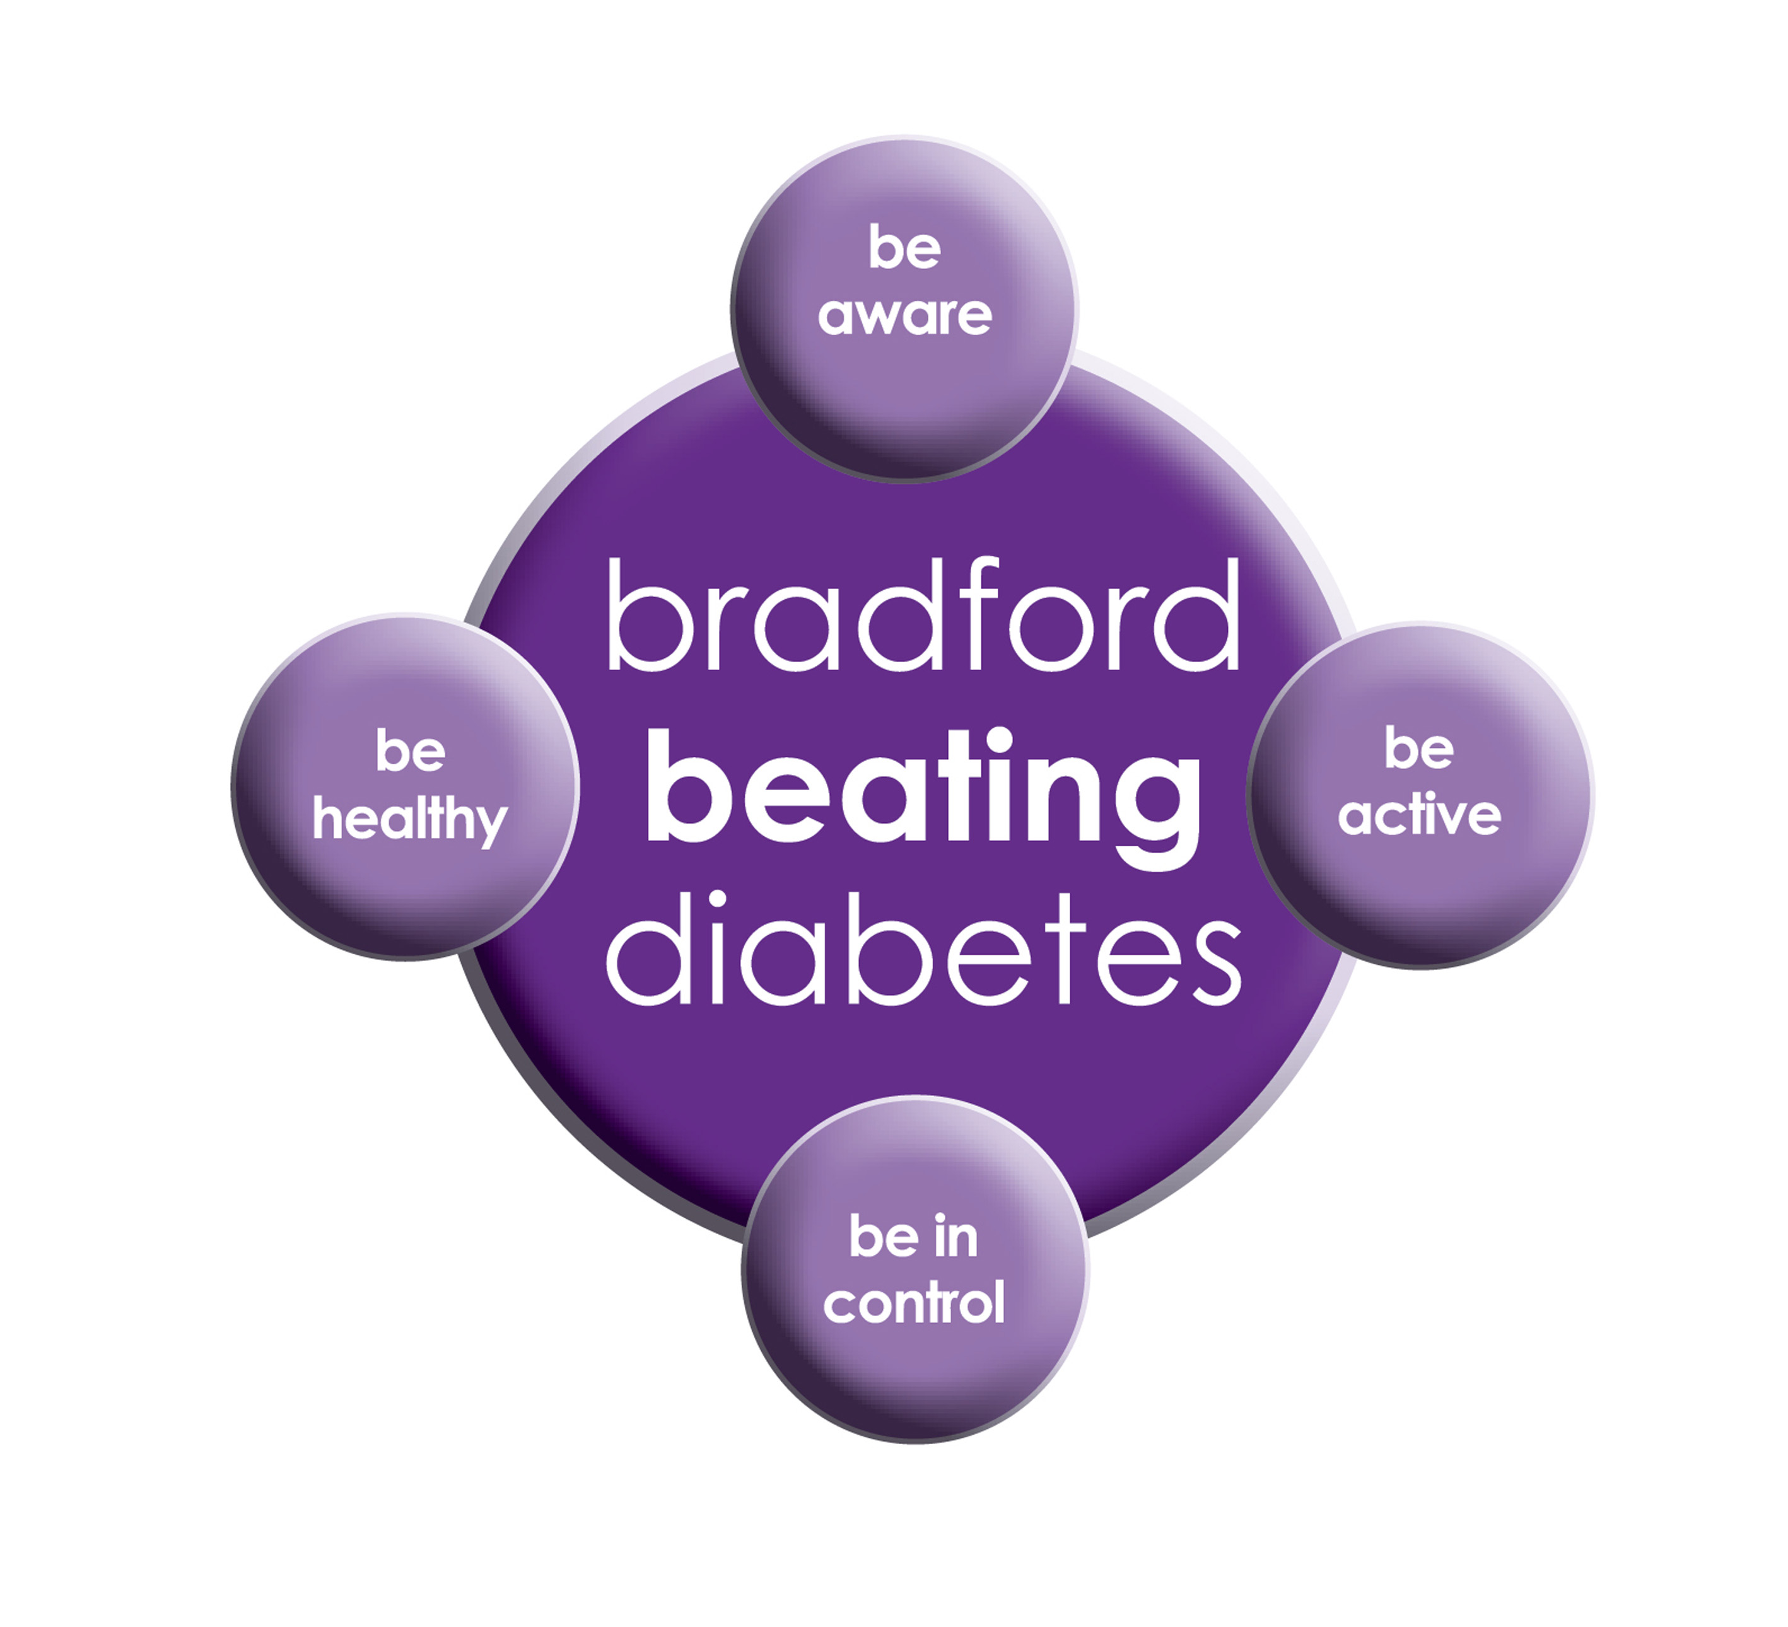

BRADFORD Beating Diabetes campaign is celebrating the success of its champions and patients who have been on the intensive lifestyle change programme.

In the 16 months since the campaign started, there have been about 1,000 newly-diagnosed patients in the city and a further 10,000 patients have received a brief lifestyle intervention from their family doctor.

The practice is inviting all adults aged over 25 (if they are from South Asian and certain other BME groups) or if they are aged over 40 (and white) and any others with conditions known to increase their risk of developing diabetes.

Some people are more at risk of developing diabetes than others:

- Those that have a family history of diabetes

- People who are overweight or have a large waist size

- People who are not physically active

- People who are south Asian or African Caribbean

**Please book an appointment if you think you are at risk of being diabetic.**

**Did Not Attend Policy:**

When a patient fails to attend an appointment *with a healthcare professional at the surgery a note of the date and time is made in their record. They are now sent a letter, If a patient fails to attend 2 appointments with a healthcare professional within a 3 month period, the patient will then receive another letter reminding them of the importance of cancelling an unwanted appointment.*

*If following this, the patient fails to attend another appointment, the Practice Manager will write to the patient informing them that they are at risk of being taken of the list, if the patient isn’t able to provide a valid explanation.*

**To cancel appointments please call:**

**01274 957908 (Grange Medical)**

**01274 957909 (Oaklane surgery)**

**Bank Holiday:**

**Please note that the surgeries will be CLOSED on:**

**Monday 26th August 2024**

**Wednesday 25 Dec 2024**

**Thursday 26th Dec 2024**

**Please contact Out Of Hours for any emergencies during those times on NHS 111**

**M Reminder For Car Parking**

GRANGE MEDICAL CENTRE PATIENT PARKING ONLY

PATIENTS/VISITORS MUST OBTAIN A PARKING PERMIT

AT RECEPTION

**Or you will be fined**

**Hay fever**

As Spring/Summer arrives, so does hay fever for many patients. The symptoms of hay fever can include runny nose, itchy throat, sneezing, itchy and watery eyes, wheeziness, and cough. It is better to go to the pharmacy and get treatment for the symptoms developing as this gives you the best opportunity to control your hay fever. Eye drops and nose sprays are very effective additions to the antihistamine tablet. Pharmacists are a wonderful source of advice regarding what can be purchased to combat hay fever over the counter.

Other minor ailments can also be dealt with at the pharmacy as well.

***Voluntary Organisations who offer Help and Support***

***Call Mind Info Line*** We're **Mind**, the mental health charity. We're here to make sure no one has to face a mental health problem alone.[**0300 123 3393**](tel:+44-300-123-3393)

If you are a young person struggling to cope, Shout can provide 24/7 text support. For help, **text SHOUT** to 85258. Whatever you are going through, if it matters to you, it matters to us.

**Samaritans UK**

Whatever you're going through, a **Samaritan** will face it with you. We're here 24 hours a day, 365 days a year. **Tel:116123**

AGE UK: Call our free, confidential advice line on 0800 678 1602. We're open 8am-7pm, 365 days a year

Carers UK

Caring for someone or a family member and need support: Call 020 7378 4999

**REPEAT PRESCRIPTIONS**

This is a kind reminder for the patients regarding repeat prescriptions. GP practices can no longer accept repeat prescription requests from pharmacies.

You (or your carer, nominated family member/friend) must order your repeat prescription from your GP practice. Please either ring the surgery at 4-6 pm or leave the prescription in the box. We are having patients ringing the surgery line at the wrong times. This causes delay answering **urgent calls**.

[](http://www.onemedicare-northstreet.co.uk/Images/CMS/Media/62-PP.jpg)

**PATIENT PARTICIPATION**

**Here at Grange Medical Centre and at Oaklane Surgery we are always keen to hear what you think about the level of care and services provided.**

**You can get involved in the work of the practice by: Joining our Patient Participation Group. Joining our Virtual Group and leaving your contact details with reception.**

**Contacting us via our practice web site at www.drirshadkhanandpartners.co.uk**

**Our Patient Participation Group meetings are held quarterly at Grange Medical Centre.**

**Any Queries contact Mrs Shamraz Akhtar our PPG Lead or email** [Shamraz.Akhtar@bradford.nhs.uk](mailto:Shamraz.Akhtar@bradford.nhs.uk)

**Tel:01274 957908**