*needed. Thank you for your time and effort.*

**Newsletter**

**GRANGE MEDICAL CENTRE/OAKLANE SURGERY**

**PATIENT NEWSLETTER**

**Spring 2018 Issue**

**Remember to…Think Speak to the Pharmacy** to get advice and medicines to treat common illnesses, such as coughs, colds, upset stomachs and skin problems . All pharmacies are more than happy to give advice and give **Over the counter Medication** if needed.

The Electronic Prescription Service (EPS)



If you get regular prescriptions, the Electronic Prescription Service (EPS) may be able to save you time by avoiding unnecessary trips to your GP.

EPS makes it possible for your prescriptions to be sent electronically to the pharmacy or dispenser of your choice. Choosing a pharmacy or dispensing appliance contractor to process your EPS prescription is called nomination.

This means you'll no longer have to collect a paper repeat prescription from your GP practice – instead, you can go straight to the nominated pharmacy or dispensing appliance contractor to pick up your medicines or medical appliances.

Because your pharmacist has already received your electronic prescription, they may be able to prepare your items in advance, so you just have to pick it up with no extra wait.

**What’s new in the practice:**

Baby clinic times have changed from: **01/02/2018 Wednesday 3.30pm till-5.30pm**

**DIABETES & HEALTH INFORMATION EVENT**

**Grange Medical Centre are collaborating with Grange Interlink Community Centre for the diabetes Event**

**on**

***Thursday 19th April 2018 11.00am 2.00pm***

*Phone: 01274 726612*

*Email:sajad@grangeInterlink.com*

[*Shakila@grangeinterlink.com*](mailto:Shakila@grangeinterlink.com)

*Shamraz Akhtar 01274 957908*

***Please attend and improve your lifestyle….***

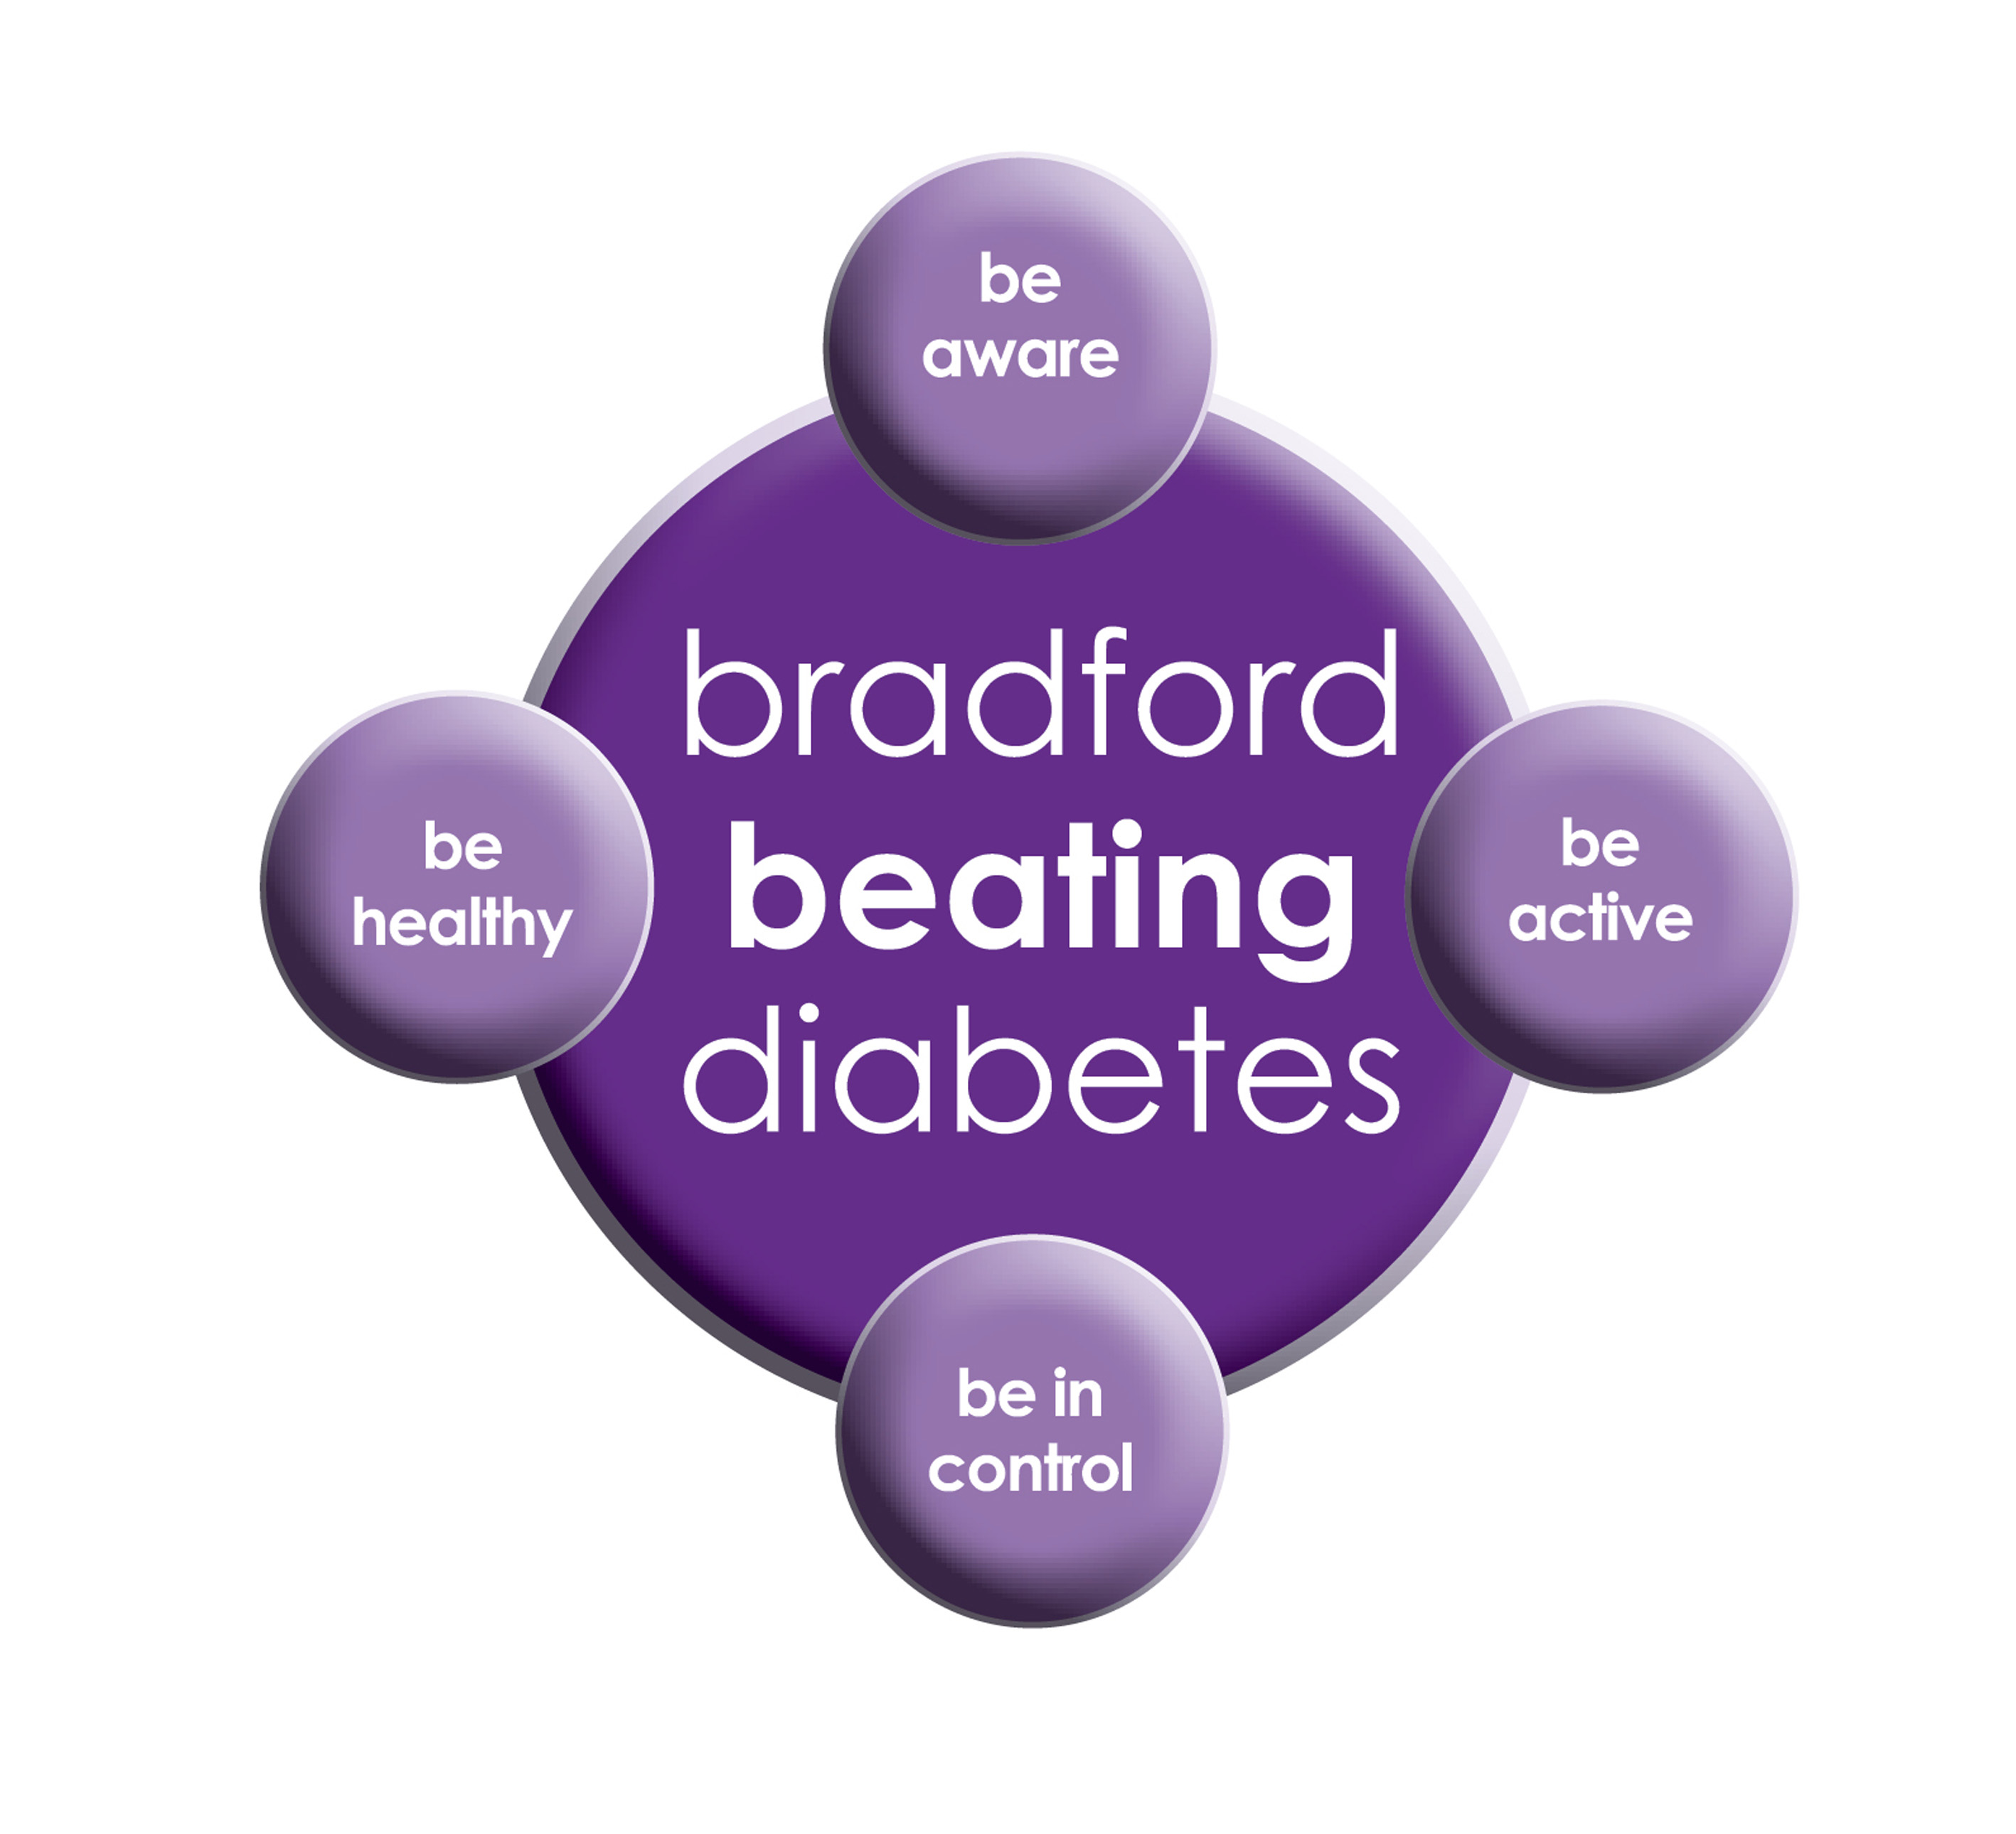

BRADFORD Beating Diabetes campaign is celebrating the success of its champions and patients who have been on the intensive lifestyle change programme.

In the 16 months since the campaign started, there have been about 1,000 newly-diagnosed patients in the city and a further 10,000 patients have received a brief lifestyle intervention from their family doctor.

The practice is inviting all adults aged over 25 (if they are from South Asian and certain other BME groups) or if they are aged over 40 (and white) and any others with conditions known to increase their risk of developing diabetes.

Some people are more at risk of developing diabetes than others:

- Those that have a family history of diabetes

- People who are overweight or have a large waist size

- People who are not physically active

- People who are south Asian or African Caribbean

**Please book an appointment if you think you are at risk of being diabetic.**

*We would like to Inform our patients that we have the* ***Care Quality Commission (CQC) team****, coming to inspect the practices @ Grange Medical Centre and Oaklane surgery on* ***the 5th April 2018***

**Up to date Telephone numbers**

**01274 957908 :Grange Medical**

**01274 957909 :Oaklane surgery**

* **Please update your mobile numbers so you can receive text reminders for your appointments.**
* **Please also sign on to online services; you will have access to more appointments.**

**Dates our Surgeries are closed:**

Please note that the surgeries will be CLOSED on:

**MONDAY 7 MAY 2018 (Bank Holiday)**

**MONDAY 28 MAY 2017 (Bank Holiday)**

Please contact Out Of Hours for any emergencies during those times on **NHS 111**

**Did Not Attend Policy:**

When a patient fails to attend an appointment *with a healthcare professional at the surgery a note of the date and time is made in their record. They are now sent a letter, If a patient fails to attend 2 appointments with a healthcare professional within a 3 month period, the patient will then receive another letter reminding them of the importance of cancelling an unwanted appointment.*

*If, following this, the patient fails to attend another appointment, the Practice Manager will write to the patient informing them that they are at risk of being taken of the list, if the patient isn’t able to provide a valid explanation.*

*In the last month we have had a total of* ***160*** *patients DNA(did not attend) appointments. These appointments could have been used by patients who required medical attention. If you do need an appointment please remember to cancel the appointment,* ***please give at least 24 hours’ notice****.*

**To cancel appointments please call:**

**01274 957908 (Grange Medical)**

**01274 957909 (Oaklane surgery)**

**Thank you in advance for filling the forms.**

**Friends and Family Forms & Feedback forms**

**We would also like our patients to carry on filling Friends and family forms and feedback forms. We would like all the feedback to improve our practice for our patients. There is a feedback box in the waiting room where you can leave the feedback.**

**Advisory Service**

We have an advisor who comes in once a week. She helps patients with benefits and housing advice.

She can help with reading important letters and filling in forms. You do not need a Doctor’s appointment to get forms filled in, the advisor may be able to do that for you if needed. If you wish to make an appointment, please contact the surgery.

**Carers resource and VCS Organisations**

A carer is someone who, provides help and support to a friend, neighbour or relative who could not manage otherwise because of frailty, illness or disability. They may even be juggling paid work with caring responsibilities at home. Carers have a tough job – it can mean unrelenting pressure, little chance to relax and a lot of worry. The system is complicated, and the issue is hidden.

The Carers’ Resource provides support for carers, no matter what their age, race, religion or needs. Follow the links on the carer’s resource website to discover what support can be offered to you as a carer, or as someone who might work with carers. At the practice we have a notice board for patients with updates and contact details if you need to get in touch with the organisation. The patients, who attend, find this service really helpful. If you would like more information please contact the carer’s resource on: **01274 449660. If you are a carer please notify your surgery we can code it on your record.**

**FREE Text Reminders for your Appointments**

**Sign up NOW and give consent so that you can receive your FREE text reminder message. Consent Forms are available from Reception.**

**Please make sure we have an up to date mobile number.**

**Would you like to sign up for newsletters by email? If so, please let the Reception have your email address.**

[](http://www.onemedicare-northstreet.co.uk/Images/CMS/Media/62-PP.jpg)

**PATIENT PARTICIPATION**

**Here at Grange Medical Centre and at Oaklane Surgery we are always keen to hear what you think about the level of care and services provided.**

**You can get involved in the work of the practice by: Joining our Patient Participation Group. Joining our Virtual Group and leaving your contact details with reception.**

**Contacting us via our practice web site at www.drirshadkhanandpartners.co.uk**

**Our Patient Participation Group meetings are held quarterly at Grange Medical Centre.**

**Any Queries contact Mrs Shamraz Akhtar our PPG Lead or email** [Shamraz.Akhtar@bradford.nhs.uk](mailto:Shamraz.Akhtar@bradford.nhs.uk)

**Tel:01274 957908**

**Community Centres**

***The local Community centres have events and different classes available for patients and advice. The classes involve Healthy lifestyle classes, Exercise classes, Healthy cooking and eating, sewing classes, swimming classes. They are very effective and low cost classes. If you are on any benefits they may be free.***

***Grange Interlink contact:***

***Tel: 01274 726612***

*Summerville Rd, Bradford BD7 1PX.*

*Opening Times: Mon- Fri 9am till 4pm*

***Khidmet Centre contact :***

***Tel: 01274 521792***

*36 Spencer Rd, Bradford BD7 2EU*

*Opening Times: Mon- Fri 9am till 5pm*

**Girlington Community Centre**:

**Tel: 01274 542454**

Girlington Rd, Bradford BD8 9NN

Opening [Hours](https://www.google.co.uk/search?q=girlington+community+centre+hours&sa=X&ved=0ahUKEwi9_qTjm4LYAhVIOJoKHcM0Bw4Q6BMIlwEwEQ): · [9am–5pm](javascript:void(0))