**NEWSLETTER Winter 2024 Issue**



**Flu Clinics**

Dear Patients

We are running flu clinics at the practice please ring the surgery and book your flu vaccine.

For most healthy people, flu is an unpleasant but usually self-limiting disease with recovery generally within a week.

However, there is a particular risk of severe illness from catching flu for:

* Older people
* The very young
* Pregnant women
* Those with underlying disease, such as chronic respiratory or cardiac disease
* Those who are immunosuppressed.
* If you are a main carer for an older or disabled person, or receive a carers allowance
* Live with someone who has a weakened immune system



**Updated Practice Website**

**We have also updated the practice website according to the NHS guidelines. The new website is user friendly for everyone. It contains pictures for easy access and easy use via the mobile phones as well.**

**Our opening hours are Monday to Friday 8am - 6:00pm. Any urgent problems outside of these hours need to be directed to NHS 111 who can give advice, arrange a home visit or book an appointment out of hours.**

**Covid Vaccines**

**We also plan to administer covid vaccinations alongside the flu vaccinations. If you are due for your covid vaccine, please query with the practice. Currently Covid vaccinations are booked with PCN 6 @ Woodroyd Centre**



**Please remember to enter your number plate when parking in the car park, otherwise you will be fined.**

**Extended Access**

The surgery will be open for extended access on Monday till 7.30pm. These appointments are for people who are unable to attend during the day. We will no longer have the extended access on Friday as the GP, Nurse and HCA are doing extended access on Monday.

**Changes to Death Registration from September 2024**

In September 2024, the process for registering a death in England and Wales changed. These updates are important for families and patients and aim to make the system more accurate. Here’s a simple guide to help you understand what this means.

1. Independent Review of All Deaths

When someone dies, a **medical examiner** or a **coroner** will now check every death. This review is done to make sure the cause of death is correct. It also gives families a chance to ask questions if they have concerns about their loved one’s care.

2. Death Certificates Will Be Reviewed

After the doctor completes a **Medical Certificate of Cause of Death (MCCD)**, a medical examiner reviews it. Once approved, the certificate is sent to the registrar, who officially records the death. This extra step helps ensure accuracy.

3. What This Means for Families

Once the medical examiner finishes the review, the family or representative of the deceased will be **notified**. After that, you can arrange to officially register the death. This needs to happen within **five days** of the death being confirmed.

4. More Time for Registration

Because of the new checks, it may take a little longer to register a death than it used to. However, this process ensures that all deaths are reviewed thoroughly, which helps improve the accuracy of death certificates.

5. Who Can Register the Death?

Under the new rules, the deceased person’s **partner** or their **legal representative** can now register the death. This change allows more people to help with this important task.

***PATCHES Services***

You can also leave a message online via PATCHES (this can be accessed via the practice website). The Message will be triaged within 72 hours. This is a service that will help people that are working late and are unable to call the Practice during core hours. A lot of patients find this service very helpful.

***Appointment System***

Practice continues to offer Face to Face and telephone appointments after messages are triaged by clinicians. The message line opens at 8.45am till 9.45am and 11.45am till 12.45pm. If there is an urgent issue the clinician on call will give the appropriate advice.

**Enhanced Access**

Enhanced Access All GP Primary Care Networks offer some appointments after 6:30pm and on Saturdays. These are for all members of our team (HCAs, nurses, blood tests, smear tests physiotherapists, and doctors, Asthma reviews, Diabetes) by ringing the surgery.

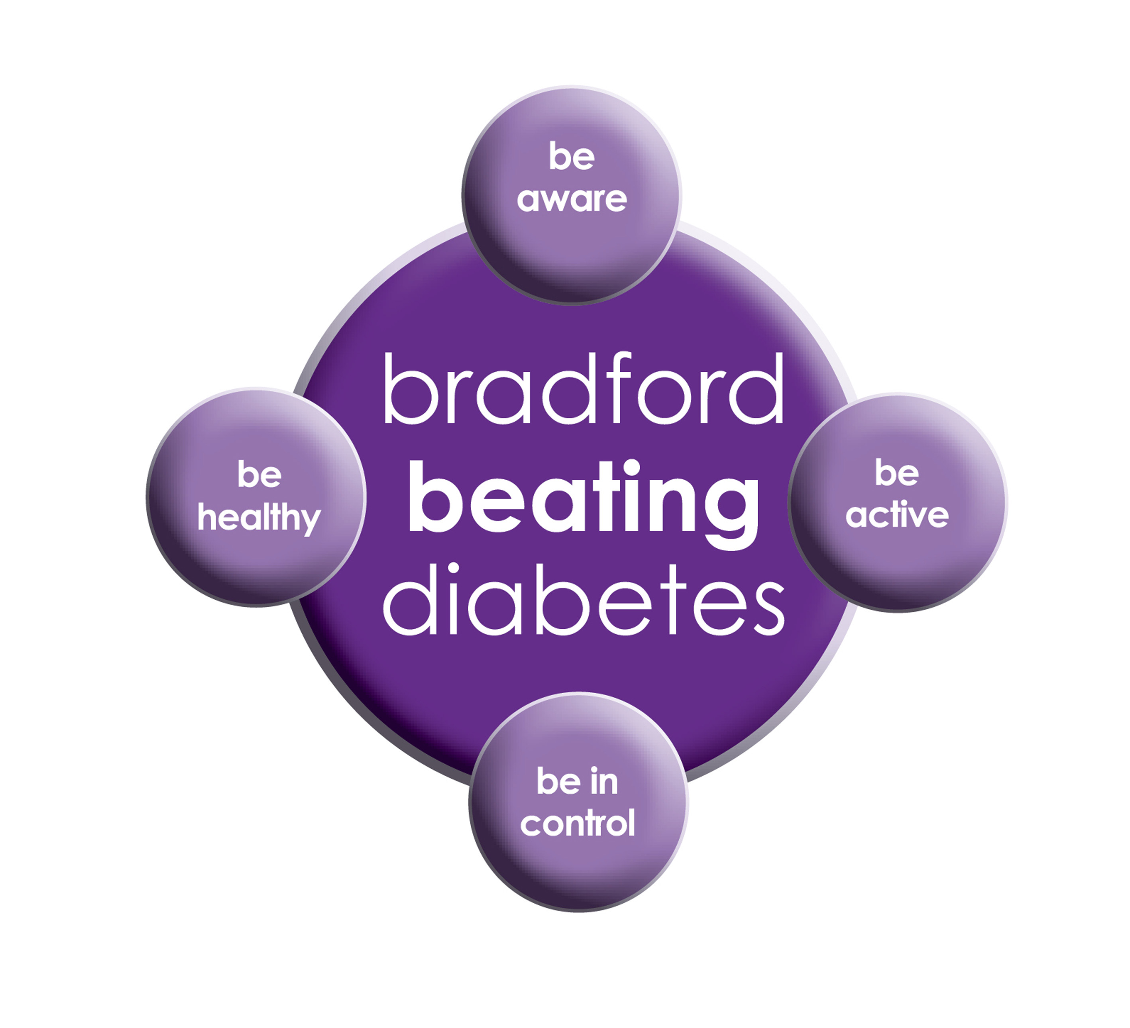

BRADFORD Beating Diabetes campaign is celebrating the success of its champions and patients who have been on the intensive lifestyle change programme.

In the 16 months since the campaign started, there have been about 1,000 newly-diagnosed patients in the city and a further 10,000 patients have received a brief lifestyle intervention from their family doctor.

The practice is inviting all adults aged over 25 (if they are from South Asian and certain other BME groups) or if they are aged over 40 (and white) and any others with conditions known to increase their risk of developing diabetes.

Some people are more at risk of developing diabetes than others:

- Those that have a family history of diabetes

- People who are overweight or have a large waist size

- People who are not physically active

- People who are south Asian or African Caribbean

**Please book an appointment if you think you are at risk of being diabetic.**

**Did Not Attend Policy:**

When a patient fails to attend an appointment *with a healthcare professional at the surgery a note of the date and time is made in their record. They are now sent a letter, If a patient fails to attend 2 appointments with a healthcare professional within a 3 month period, the patient will then receive another letter reminding them of the importance of cancelling an unwanted appointment.*

*If following this, the patient fails to attend another appointment, the Practice Manager will write to the patient informing them that they are at risk of being taken of the list, if the patient isn’t able to provide a valid explanation.*

**To cancel appointments please call:**

**01274 957908 (Grange Medical)**

**01274 957909 (Oaklane surgery)**

**Bank Holiday:**

**Please note that the surgeries will be CLOSED on:**

**Wednesday 25 Dec 2024**

**Thursday 26th Dec 2024**

**Wednesday 1st January 2024**

**Please contact Out Of Hours for any emergencies during those times on NHS 111**

**M Reminder For Car Parking**

GRANGE MEDICAL CENTRE PATIENT PARKING ONLY

PATIENTS/VISITORS MUST OBTAIN A PARKING PERMIT

AT RECEPTION

**Or you will be fined**

**Staying Warm During Cold Weather**

Cold weather can pose health risks, particularly for older adults, young children, and those with chronic illnesses. Staying warm is essential to reduce the risk of illnesses like colds, flu, and more serious conditions.

***Voluntary Organisations who offer Help and Support***

***Call Mind Info Line*** We're **Mind**, the mental health charity. We're here to make sure no one has to face a mental health problem alone.[**0300 123 3393**](tel:+44-300-123-3393)

If you are a young person struggling to cope, Shout can provide 24/7 text support. For help, **text SHOUT** to 85258. Whatever you are going through, if it matters to you, it matters to us.

**Samaritans UK**

Whatever you're going through, a **Samaritan** will face it with you. We're here 24 hours a day, 365 days a year. **Tel:116123**

AGE UK: Call our free, confidential advice line on 0800 678 1602. We're open 8am-7pm, 365 days a year

Carers UK

Caring for someone or a family member and need support: Call 020 7378 4999

**Cervical Screening**

Screening means testing for early signs of an illness before you have symptoms. Cervical screening picks up changes in the cells covering the cervix (the neck of your womb) that could develop into cancer in the future. It isn’t a test for cancer. It’s a test for abnormal pre-cancerous changes in these cells, which can then be treated to stop cancer developing. Cervical screening is highly effective at preventing cervical cancer. It saves around 4,500 lives every year in England alone.

**Breast Screening**

Women between the ages of 50 and 70 are now routinely invited for free screening every three years. Patients who have **missed** their appointments can still get the screening done. Please ring the department on

[**Phone**](https://www.google.co.uk/search?q=pennine+breast+screening+service+phone&ludocid=4991663712128620368&sa=X&ved=2ahUKEwiY2J3J-ZvlAhWGN8AKHY7pBR8Q6BMwE3oECAsQKw)**: 01274 365521**

**Bowel cancer screening**

Bowel cancer screening aims to check for bowel cancer or abnormalities that could lead to bowel cancer. The screening tests include:

* testing for blood in your poo (stools)
* looking inside your bowel using a scope (bowel scope)