*needed. Thank you for your time and effort.*

**Newsletter**

**GRANGE MEDICAL CENTRE/OAKLANE SURGERY**

**PATIENT NEWSLETTER**

**Bowel cancer screening**

***Appointment System***

We are booking patients for Face to Face appointments and Telephone appointments. You will be triaged on the day when you ring the surgery. The message line opens at 8.45 till 9.45 and 11.45 till 12.45. If there is an urgent issue the clinician on call will give the appropriate advice.

***E-Consults***

You can also leave an E-consult online. The E-consult will be triaged within 72 hours. This is a service that will help people that are working late and are unable to ring the surgery. A lot of patients find this service very helpful.

**Cervical Screening**

Screening means testing for early signs of an illness before you have symptoms. Cervical screening picks up changes in the cells covering the cervix (the neck of your womb) that could develop into cancer in the future. It isn’t a test for cancer. It’s a test for abnormal pre-cancerous changes in these cells, which can then be treated to stop cancer developing. Cervical screening is highly effective at preventing cervical cancer. It saves around 4,500 lives every year in England alone.

**Breast Screening**

Women between the ages of 50 and 70 are now routinely invited for free screening every three years. Patients who have DNA’d there appointments can still get the screening done. Please ring the department on

[**Phone**](https://www.google.co.uk/search?q=pennine+breast+screening+service+phone&ludocid=4991663712128620368&sa=X&ved=2ahUKEwiY2J3J-ZvlAhWGN8AKHY7pBR8Q6BMwE3oECAsQKw)**: 01274 365521**

**Bowel cancer screening**

Bowel cancer screening aims to check for bowel cancer or abnormalities that could lead to bowel cancer. The screening tests include:

* testing for blood in your poo (stools)
* looking inside your bowel using a scope (bowel scope)

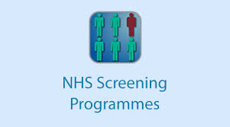

**Autumn/ Winter 2022 Issue**

**Flu Vaccinations:**

**We will be receiving our delivery of the flu vaccines soon. We will inform our patients of the appointments that are available. We will be holding clinics when we have staff rotas.**

## ****Why get the vaccine and who is eligible?****

**The flu vaccine remains the best defense we have against flu and protects those people who are most vulnerable.**

**Certain groups of people are at higher risk from flu, including adults aged 65 and over, those with underlying health conditions, pregnant women, and frontline health and social care workers.**

**The flu vaccination will be offered to:**

* **\*Those aged 65 years and over, those aged 6 months to * Under 65 years in clinical risk groups.**
* **\* Pregnant women.**
* **\* Those living in a residential or nursing home.**
* **\* The main carer of an older or disabled person.**
* **\* All children aged 2 or 3 years on 31 August 2022**
* **\*All primary school aged children (from reception to Year 6)**
* **and certain other risk groups eligible.**
* **Employers of frontline health and social care workers also have a responsibility to ensure their staff can get the free vaccine.**

## ****How can I protect myself, my family and those around me from the flu?****

**The vaccine remains the best defence we have to protect against the spread of flu and we encourage everyone eligible to get it each year.**

**Covid Vaccines**

**We also plan to administer covid vaccinations alongside the flu vaccinations. If you are due for your covid vaccine, please query with the practice. Seasonal Covid vaccinations will be available as well.**

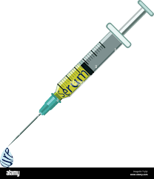

**Please remember to enter your number plate when parking in the car park, otherwise you will be fined.**

**Extended Access**

The surgery will be open for extended access on Monday till 7.30pm. These appointments are for people who are unable to attend during the day. We will no longer have the extended access on Friday as the GP, Nurse and HCA are doing extended access on Monday.

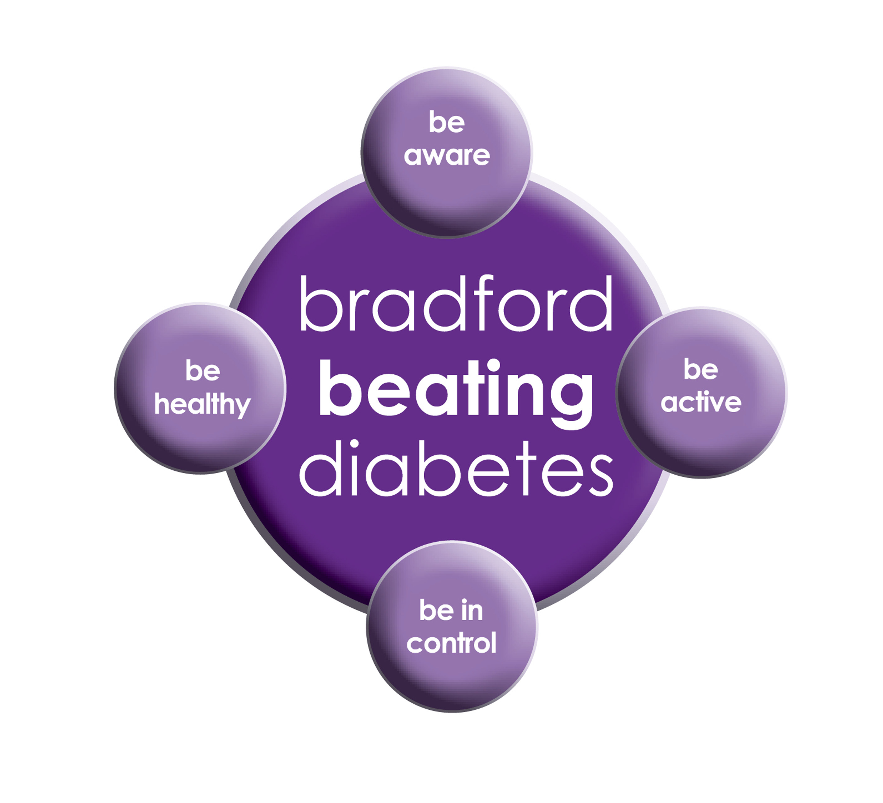

BRADFORD Beating Diabetes campaign is celebrating the success of its champions and patients who have been on the intensive lifestyle change programme.

In the 16 months since the campaign started, there have been about 1,000 newly-diagnosed patients in the city and a further 10,000 patients have received a brief lifestyle intervention from their family doctor.

The practice is inviting all adults aged over 25 (if they are from South Asian and certain other BME groups) or if they are aged over 40 (and white) and any others with conditions known to increase their risk of developing diabetes.

Some people are more at risk of developing diabetes than others:

- Those that have a family history of diabetes

- People who are overweight or have a large waist size

- People who are not physically active

- People who are south Asian or African Caribbean

**Please book an appointment if you think you are at risk of being diabetic.**

**Dates our Surgeries are closed:**

**Please note that the surgeries will be CLOSED on:**

**Monday 26th December 2022 bank holiday**

**Tuesday 27th December 2022**

**Monday 2nd January 2023**

**Please contact Out Of Hours for any emergencies during those times on NHS 111**

**Did Not Attend Policy:**

When a patient fails to attend an appointment *with a healthcare professional at the surgery a note of the date and time is made in their record. They are now sent a letter, If a patient fails to attend 2 appointments with a healthcare professional within a 3 month period, the patient will then receive another letter reminding them of the importance of cancelling an unwanted appointment.*

*If following this, the patient fails to attend another appointment, the Practice Manager will write to the patient informing them that they are at risk of being taken of the list, if the patient isn’t able to provide a valid explanation.*

*In the last month we have had a total of* ***186*** *patients DNA(did not attend) appointments. These appointments could have been used by patients who required medical attention. If you do need an appointment please remember to cancel the appointment,* ***please give at least 24 hours’ notice****.*

**To cancel appointments please call:**

**01274 957908 (Grange Medical)**

**01274 957909 (Oaklane surgery)**

**M ED IPARKING CONDITIONS**

GRANGE MEDICAL CENTRE PATIENT PARKING ONLY

PATIENTS/VISITORS MUST OBTAIN A PARKING PERMIT

AT RECEPTION

**Or you will be fined**

# *Winter Self Care Advice*

Many of us will have a cold, sore throat or other minor illness at some point during the winter and some of us will have flu. The most common winter illnesses will usually get better without the need to see a doctor.

***Speak to your pharmacist***

 Your local pharmacy can recognise many common health complaints. They can give advice or, where appropriate, medicines to help you manage the symptoms.  If your problem is more serious or you need medical advice, your pharmacist will advise you to contact your GP.

You can also ask your pharmacist what over the counter remedies to keep in your medicine cabinet at home to help get you and your family through the winter months.

**FREE Text Reminders for your Appointments**

**Sign up NOW and give consent so that you can receive your FREE text reminder message. Consent Forms are available from Reception.**

**Please make sure we have an up to date mobile number.**

**Would you like to sign up for newsletters by email? If so, please let the Reception have your email address.**

**REPEAT PRESCRIPTIONS**

This is a kind reminder for the patients regarding repeat prescriptions. GP practices can no longer accept repeat prescription requests from pharmacies.

You (or your carer, nominated family member/friend) must order your repeat prescription from your GP practice. Please either ring the surgery at 4-6 pm or leave the prescription in the box. We are having patients ringing the surgery line at the wrong times. This causes delay answering **urgent calls**.

**Community Centres**

***The local Community centres have events and different classes available for patients and advice. The classes involve Healthy lifestyle classes, Exercise classes, Healthy cooking and eating, sewing classes, swimming classes. They are very effective and low cost classes. If you are on any benefits they may be free.***

***Grange Interlink contact:***

***Tel: 01274 726612***

*Summerville Rd, Bradford BD7 1PX.*

*Opening Times: Mon- Fri 9am till 4pm*

***Khidmet Centre contact :***

***Tel: 01274 521792***

*36 Spencer Rd, Bradford BD7 2EU*

*Opening Times: Mon- Fri 9am till 5pm*

**Girlington Community Centre**:

**Tel: 01274 542454**

Girlington Rd, Bradford BD8 9NN

Opening [Hours](https://www.google.co.uk/search?q=girlington+community+centre+hours&sa=X&ved=0ahUKEwi9_qTjm4LYAhVIOJoKHcM0Bw4Q6BMIlwEwEQ): · [9am–5pm](javascript:void(0))

[](http://www.onemedicare-northstreet.co.uk/Images/CMS/Media/62-PP.jpg)

**PATIENT PARTICIPATION**

**Here at Grange Medical Centre and at Oaklane Surgery we are always keen to hear what you think about the level of care and services provided.**

**You can get involved in the work of the practice by: Joining our Patient Participation Group. Joining our Virtual Group and leaving your contact details with reception.**

**Contacting us via our practice web site at www.drirshadkhanandpartners.co.uk**

**Our Patient Participation Group meetings are held quarterly at Grange Medical Centre.**

**Any Queries contact Mrs Shamraz Akhtar our PPG Lead or email** [Shamraz.Akhtar@bradford.nhs.uk](mailto:Shamraz.Akhtar@bradford.nhs.uk)

**Tel:01274 957908**