**Newsletter**

**GRANGE MEDICAL CENTRE/OAKLANE SURGERY**

**PATIENT NEWSLENNTTER**

**February 2017 Issue**

**Flu Vaccines 2016/17**

Most of the patients who are at risk have had their influenza injection. If any patient thinks they need a flu injection and haven’t had it done, please inform the surgery.

**Anyone in these risk groups is more likely to develop potentially serious** [**complications of flu**](http://www.nhs.uk/Conditions/Flu/Pages/Complications.aspx)**, such as**[**pneumonia**](http://www.nhs.uk/conditions/Pneumonia/Pages/Introduction.aspx) **(a lung infection), so it's recommended that they have a flu vaccine every year to protect them.**

**At risk group include:**

* **All over 65**
* **Any age with certain long term conditions such as Asthma/COPD, heart problems or past stroke and diabetes**
* **Pregnancy at any stage**
* **If you are a carer**

**The flu vaccine is also given on the NHS as an annual** [**nasal spray**](http://www.nhs.uk/Conditions/vaccinations/Pages/child-flu-vaccine.aspx) **to:**

**Healthy children aged two, three and four years old plus children in school years one and two and children aged two to 17 years at a particular risk of flu.**

**Up to date Telephone numbers**

**01274 957908 :Grange Medical**

**01274 957909 :Oaklane surgery**

* **Please update your mobile numbers so you can receive text reminders for your appointments.**
* **Please also sign on to online services; you will have access to more appointments.**

**Top 100 Attenders**

**The practice are identifying the Top 100 attenders and signposting them to the right area of help. It maybe you need the help of a pharmacist, benefits advisor, carers team, or any other voluntary organisation. We can direct you to the right person to help. We try accommodating all requests. The GPs are here to help and provide a service to urgent or acute medical problems for patients. So please consider why you are attending and is it the help of the GP you need. If you are unsure please ask the reception staff about the help available.**

**Top 20 DNAs**

**We are also identifying the Top 20 patients who miss their appointments and do not notify the surgery. Again the patients who need urgent appointments miss out on appointments. Please notify the surgery if you are unable to attend.**

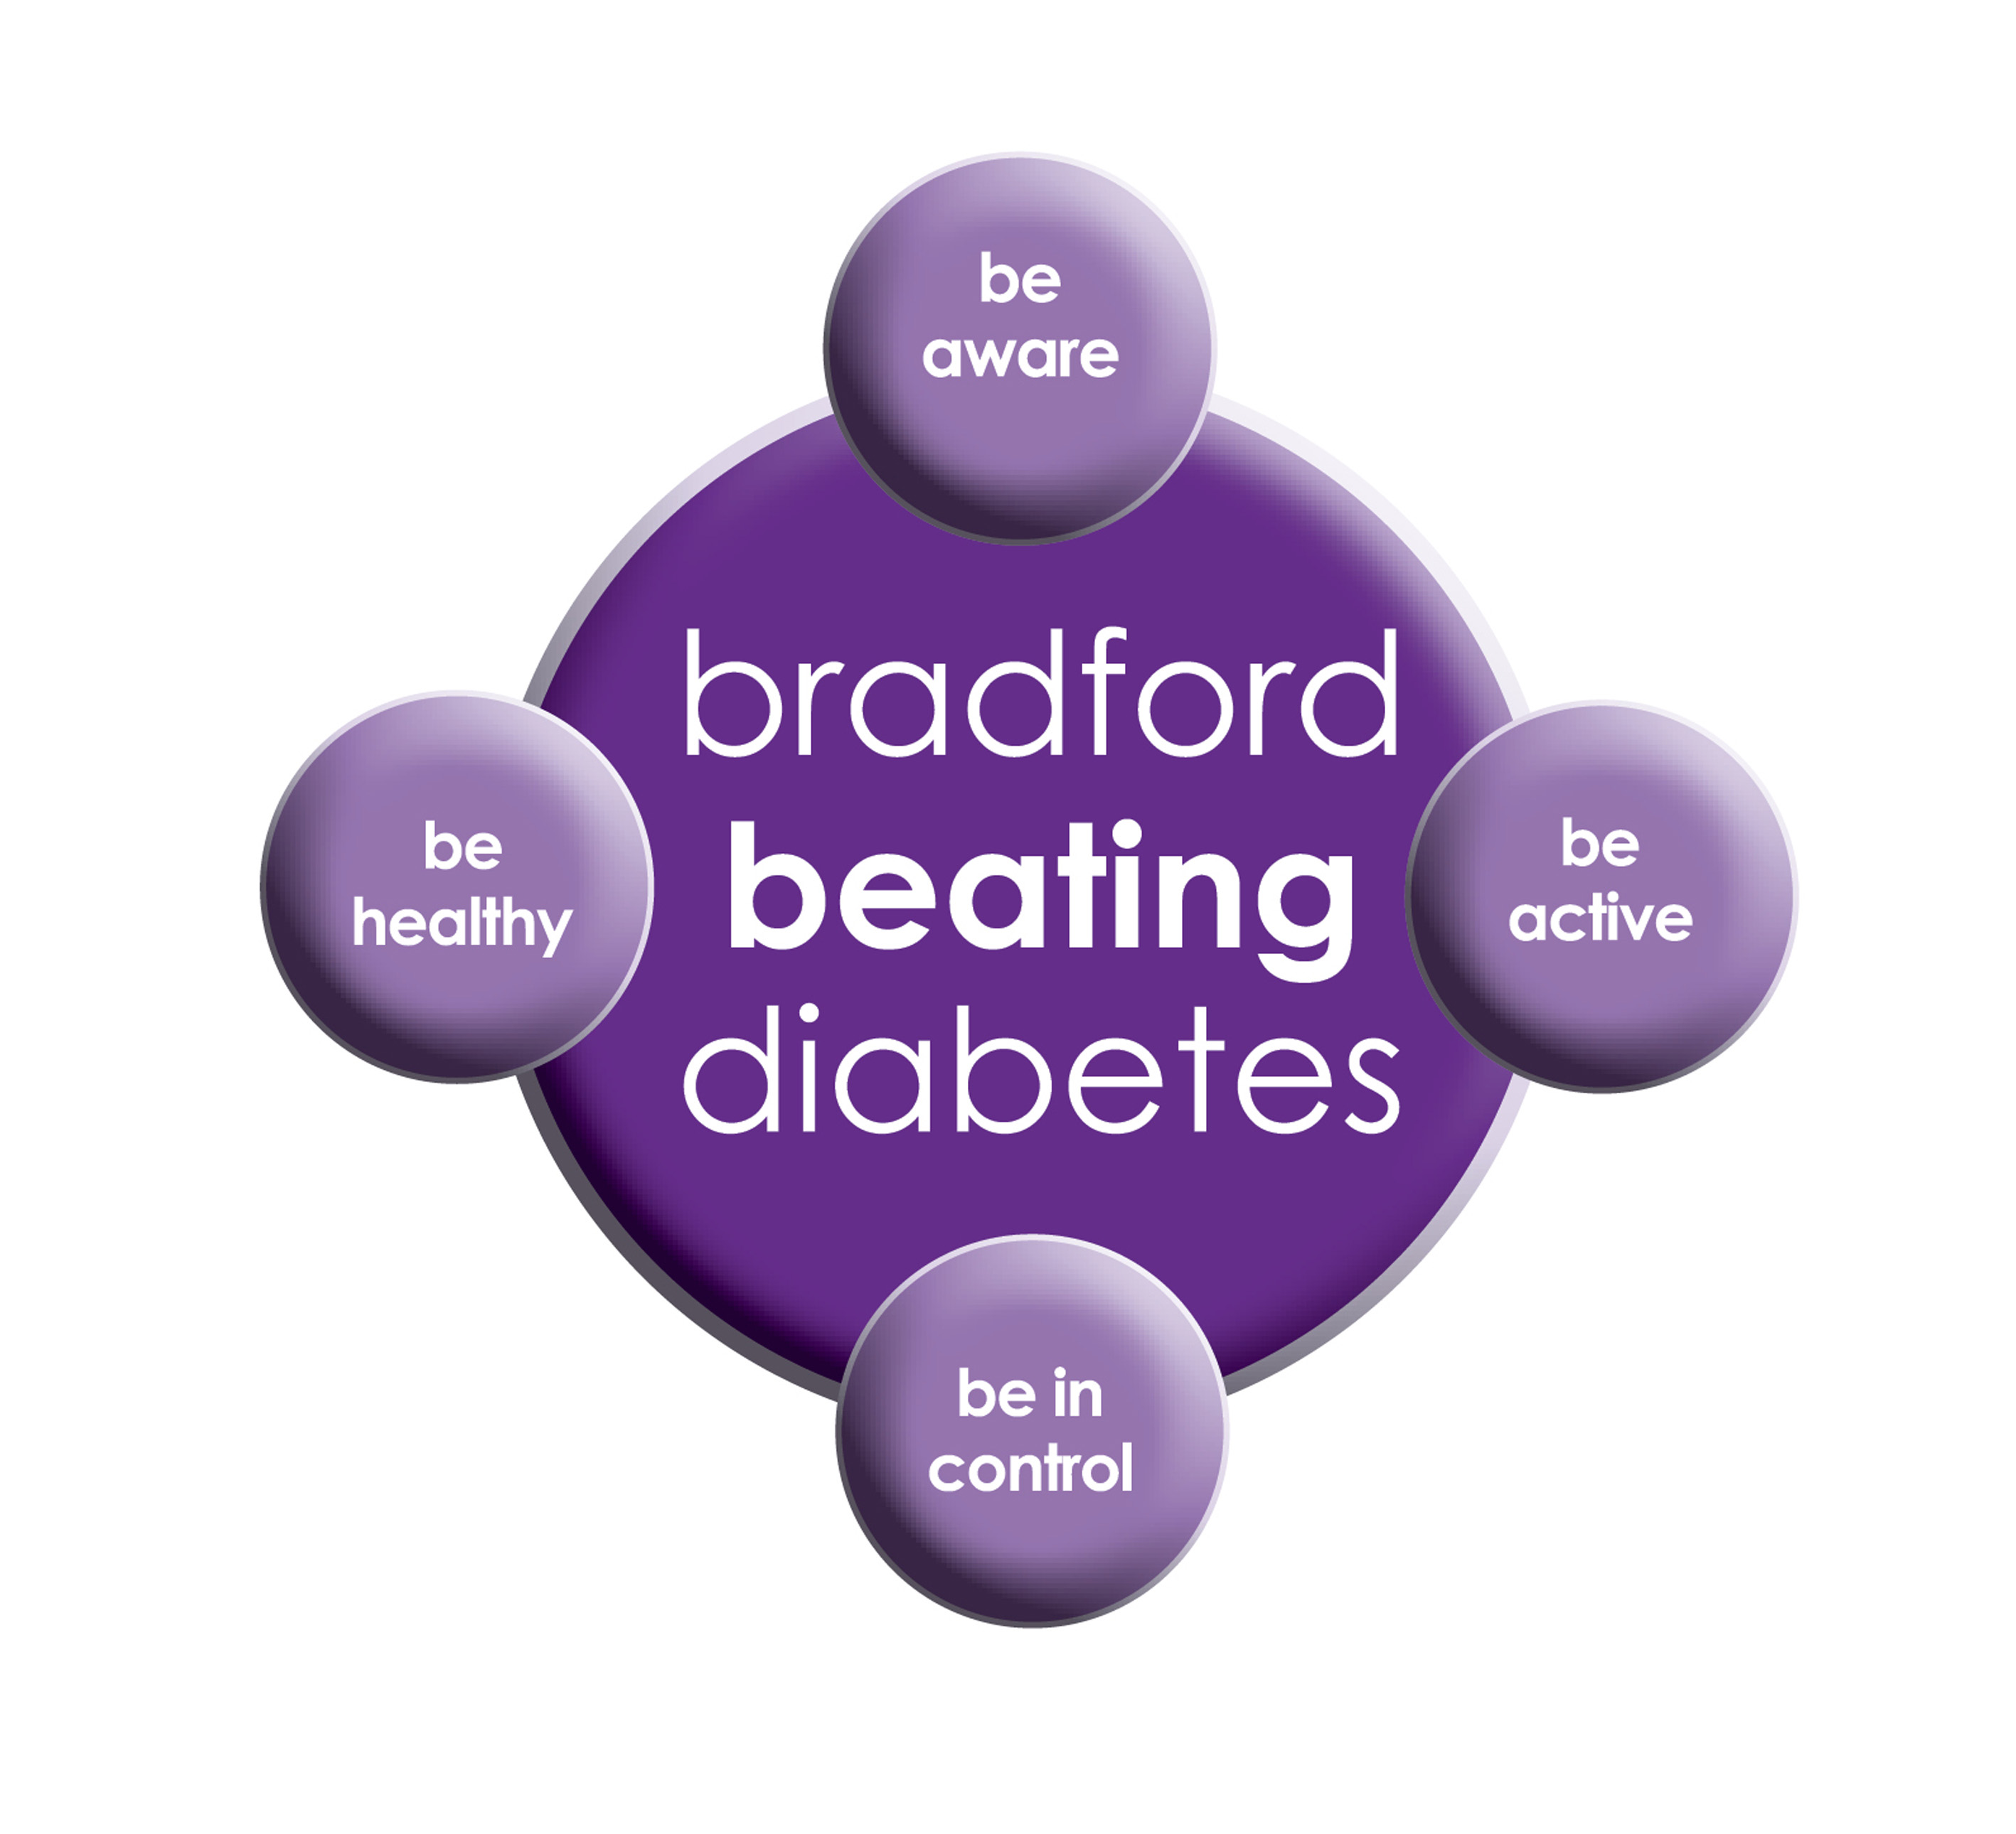

BRADFORD Beating Diabetes campaign is celebrating the success of its champions and patients who have been on the intensive lifestyle change programme.

In the 16 months since the campaign started, there have been about 1,000 newly-diagnosed patients in the city and a further 10,000 patients have received a brief lifestyle intervention from their family doctor.

The practice is inviting all adults aged over 25 (if they are from South Asian and certain other BME groups) or if they are aged over 40 (and white) and any others with conditions known to increase their risk of developing diabetes.

Some people are more at risk of developing diabetes than others:

- Those that have a family history of diabetes

- People who are overweight or have a large waist size

- People who are not physically active

- People who are south Asian or African Caribbean

**Please book an appointment if you think you are at risk of being diabetic.**

***Healthy Eating Advice***



*A healthy diet should include a wide variety of nutritious foods for sufficient intake of all nutrients, including vitamins and minerals. Foods to include are breads, pastas, lean meats, fish, fruits and vegetables. A healthy diet can help you maintain a healthy body weight and decrease your risk of many diet-related chronic diseases, such as cardiovascular disease, type 2 diabetes and some cancers.*

**Over the counter Medication**

There are many over-the-counter medications available without a prescription, which are used to treat the symptoms of many illnesses and don't usually require the help of a Doctor. You can buy medication for symptoms like:

* **Minor aches and pains,**
* [**Fever**](http://www.emedicinehealth.com/fever_in_adults/article_em.htm)**,**
* [**Diarrhea**](http://www.emedicinehealth.com/diarrhea/article_em.htm)**,**
* [**Cold**](http://www.emedicinehealth.com/colds/article_em.htm)**symptoms,**
* [**Sore throat**](http://www.emedicinehealth.com/sore_throat/article_em.htm)
* [**Allergies**](http://www.emedicinehealth.com/slideshow_10_common_allergy_triggers/article_em.htm)**.**

Pharmacists can also give you help and advice on other minor ailments.

**Carers resource and VCS Organisations**

A carer is someone who, without payment, provides help and support to a friend, neighbour or relative who could not manage otherwise because of frailty, illness or disability. They may even be juggling paid work with caring responsibilities at home. Carers have a tough job – it can mean unrelenting pressure, little chance to relax and a lot of worry. The system is complicated, and the issue is hidden.

The Carers’ Resource provides support for carers, no matter what their age, race, religion or needs. Follow the links on the carer’s resource website to discover what support can be offered to you as a carer, or as someone who might work with carers. At the practice we have a notice board for patients with updates and contact details if you need to get in touch with the organisation. The patients, who attend, find this service really helpful.

If you would like more information please contact the carer’s resource on: **01274 449660**

**Advisory Service**

We have an advisor who comes in once a week. She helps patients with benefits and housing advice.

She can help reading important letters and filling in forms. You do not need a Doctor’s appointment to get forms filled in the advisor may be able to do that for you if needed. If you wish to make an appointment, please contact the surgery.

**Community Centres**

***The local Community centres have events and different classes available for patients and advice. The classes involve Healthy lifestyle classes, Exercise classes, Healthy cooking and eating, sewing classes, swimming classes. They are very effective and low cost classes. If you are on any benefits they may be free.***

***Grange Interlink contact: 01274 726612***

***Khidmet Centre contact : 01274 521792***

***Girlington Community Centre: 01274 542454***

**FRIENDS AND FAMILY TEST , NATIONAL SURVEYS & FEEDBACK FORMS**

**We would like to know how likely you are to recommend our practice to friends and family if they needed treatment. Please fill in the questionnaires on the reception desk or online.**

**We will also be handing out our questionnaires for 2017, please take a few minutes of your time to fill in the questionnaires. This will help the practice to improve in any areas needed. It will also give us an idea about what our patients think of the practice.**

**If you are sent any national surveys please do fill them in, if you need any help please come to the surgery our staff members will be more than happy to assist you.**

**FREE Text Reminders for your Appointments**

**Sign up NOW and give consent so that you can receive your FREE text reminder message. Consent Forms are available from Reception.**

**If you don’t attend appointments you may be taken of the list.**

[](http://www.onemedicare-northstreet.co.uk/Images/CMS/Media/62-PP.jpg)

**PATIENT PARTICIPATION**

**Here at Grange Medical Centre and at Oaklane Surgery we are always keen to hear what you think about the level of care and services provided.**

**You can get involved in the work of the practice by: Joining our Patient Participation Group.**

**Joining our Virtual Group and leaving your contact details with reception.**

**Contacting us via our practice web site at www.drirshadkhanandpartners.co.uk**

**Our Patient Participation Group meetings are held quarterly at Grange Medical Centre.**

**Any Queries contact Mrs Shamraz Akhtar our PPG Lead or email** [**Shamraz.Akhtar@bradford.nhs.uk**](mailto:Shamraz.Akhtar@bradford.nhs.uk)

**Good News For Our Patients**

**We have more online appointments available to**

**book seven days in advance, two days in**

**advance and on the day. This was suggested**

**by our patients and PPG members.**

**We appreciate your valuable suggestions.**

**We would like to welcome our new apprentice Saira Jangir**