*needed. Thank you for your time and effort.*

**Newsletter**

**GRANGE MEDICAL CENTRE/OAKLANE SURGERY**

**PATIENT NEWSLETTER**

**Winter 2017 Issue**

**Did Not Attend Policy:**

When a patient fails to attend an appointment *with a healthcare professional at the surgery a note of the date and time is made in their record. If a patient fails to attend 2 appointments with a healthcare professional within a 3 month period, the patient will then receive a letter reminding them of the importance of cancelling an unwanted appointment.*

*If, following this, the patient fails to attend another appointment) the Practice Manager will write to the patient informing them that they are at risk of being taken of the list, if the patient isn’t able to provide a valid explanation.*

*In the last month we have had a total of* ***280*** *patients (did not attend) appointments. These appointments could have been used by patients who required medical attention. If you do need an appointment please remember to cancel the appointment,* ***please give at least 24 hours’ notice****.*

**To cancel appointments please call:**

**01274 957908 (Grange Medical)**

**01274 957909 (Oaklane surgery)**

**Winter Advice & Self Care**

**Winter tiredness**

Many people feel tired and sluggish during winter. This is due to the lack of sunlight, which disrupts our sleep and waking cycles. Try getting outdoors in natural **daylight** as much as possible. Get a **good night's sleep** go to bed and wake up at the same time every day.

**Destress** with exercise or meditation – stress has been shown to make you feel tired

**Eat more fruit and veg**

When it's cold and dark outside, it can be tempting to fill up on unhealthy comfort food. However, it's important to ensure you still have a healthy diet and include five portions of fruit and veg a day

**Drink more milk**

You are more likely to get a [cold](https://www.nhs.uk/conditions/Cold-common/Pages/Introduction.aspx) in winter, so make sure your immune system is in tip-top condition.

Milk and dairy products such as cheese, yoghurt and fromage frais are great sources of:

* Protein
* Vitamins A and B12
* Calcium, which helps keep our bones strong

**Try new activities for the whole family**

**Up to date Telephone numbers**

**01274 957908 :Grange Medical**

**01274 957909 :Oaklane surgery**

* **Please update your mobile numbers so you can receive text reminders for your appointments.**
* **Please also sign on to online services; you will have access to more appointments.**

**Over the counter Medication**

The CQC have advised that patients get over-the-counter medications without a prescription, which are used to treat the symptoms of many illnesses and don't usually require the help of a Doctor. You can buy medication for symptoms like:

* Minor aches and pains,
* [Fever](http://www.emedicinehealth.com/fever_in_adults/article_em.htm)
* [Diarrhea](http://www.emedicinehealth.com/diarrhea/article_em.htm),
* [Cold](http://www.emedicinehealth.com/colds/article_em.htm) symptoms,
* [Sore throat](http://www.emedicinehealth.com/sore_throat/article_em.htm)/coughs
* [Allergies](http://www.emedicinehealth.com/slideshow_10_common_allergy_triggers/article_em.htm).
* Constipation
* Hay fever
* Head lice
* Headache and fever
* Heartburn and indigestion
* Insect bites and stings

**Pharmacists can also give you help and advice on other minor ailments.**

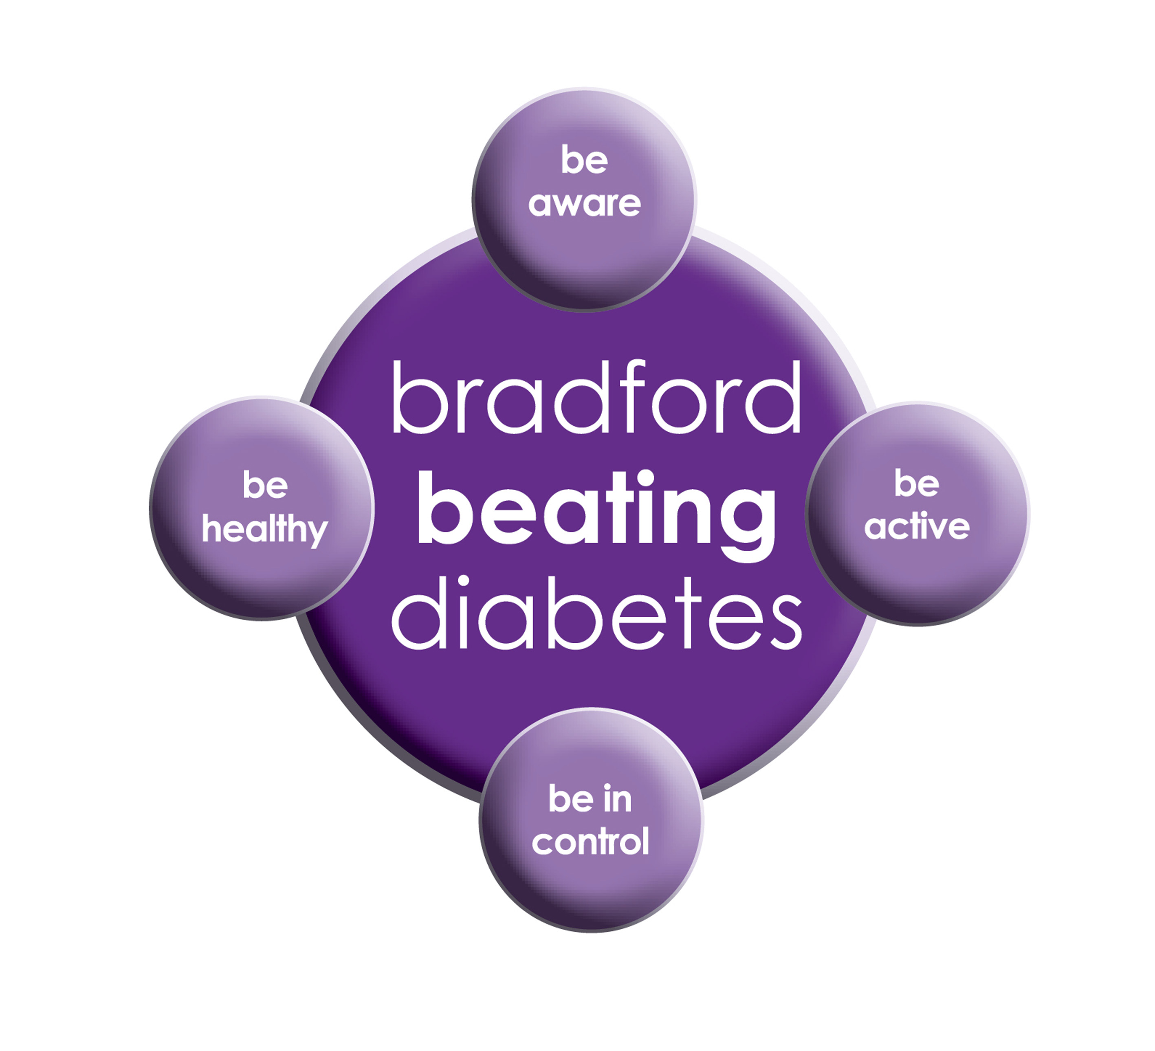

BRADFORD Beating Diabetes campaign is celebrating the success of its champions and patients who have been on the intensive lifestyle change programme.

In the 16 months since the campaign started, there have been about 1,000 newly-diagnosed patients in the city and a further 10,000 patients have received a brief lifestyle intervention from their family doctor.

The practice is inviting all adults aged over 25 (if they are from South Asian and certain other BME groups) or if they are aged over 40 (and white) and any others with conditions known to increase their risk of developing diabetes.

Some people are more at risk of developing diabetes than others:

- Those that have a family history of diabetes

- People who are overweight or have a large waist size

- People who are not physically active

- People who are south Asian or African Caribbean

**Please book an appointment if you think you are at risk of being diabetic.**

***National Survey***

*We would like to inform our patients that the next National Survey will be sent out in January 2018. Please fill the survey forms and send them back. We would really appreciate you filling the forms and replying back with your feedback.*

*If you are unable to fill the form or need help please bring the form to the surgery and we will help you.*

**Thank you in advance for filling the forms.**

**Friends and Family Forms & Feedback forms**

**We would also like our patients to carry on filling Friends and family forms and feedback forms. We would like all the feedback to improve for our practice for our patients. There is a feedback box in the waiting room where you can leave the feedback.**

[](http://www.google.co.uk/url?url=http://www.clipartpanda.com/categories/pharmacy-building-clipart&rct=j&frm=1&q=&esrc=s&sa=U&ved=0ahUKEwiZpoqBqYPVAhWII8AKHf1hBUMQwW4IHDAD&usg=AFQjCNF_SYIvpK98UK5c4FG4rLYMGwyyUA)

# The Flu Vaccination

**Flu vaccination** is available every year on the NHS to help protect adults and children at risk of flu and its complications. Flu can be more severe in certain people, such as:

* anyone aged 65 and over
* pregnant women
* children and adults with an underlying health condition (such as long-term heart or respiratory disease)
* children and adults with weakened immune systems

Anyone in these risk groups is more likely to develop potentially serious [complications of flu](https://www.nhs.uk/Conditions/Flu/Pages/Complications.aspx), such as [pneumonia](https://www.nhs.uk/conditions/Pneumonia/Pages/Introduction.aspx) (a lung infection), so it's recommended that they have a flu vaccine every year to protect them.

The injected flu vaccine is offered free on the NHS annually to:

* adults over the age of 18 at risk of flu due to a particular condition (including everyone aged 65 and over)
* pregnant women
* children aged six months to two years at risk of flu

Flu nasal spray vaccination: The flu vaccine is routinely given on the NHS as an annual [nasal spray](https://www.nhs.uk/Conditions/vaccinations/Pages/child-flu-vaccine.aspx) to:

* children aged two and three plus children in reception class and school years one, two, three and four.
* children aged two to 17 years in a particular risk group of flu

[](https://www.google.co.uk/imgres?imgurl=http%3A%2F%2Fmedia.empr.com%2Fimages%2F2017%2F08%2F28%2Ffluseasonss349387703_1280240.jpg%3Fformat%3Djpg%26zoom%3D1%26quality%3D70%26anchor%3Dmiddlecenter%26width%3D320%26mode%3Dpad&imgrefurl=http%3A%2F%2Fwww.empr.com%2Fnews%2Fflu-season-vaccine-quadrivalent-trivalent-acip%2Farticle%2F684558%2F&docid=7qpMSnvGzswW6M&tbnid=sHPlgGrpVQVrHM%3A&vet=10ahUKEwi578z2oILYAhUEAZoKHZgaB0cQMwjsASgPMA8..i&w=320&h=141&bih=651&biw=1024&q=influenza%20vaccine&ved=0ahUKEwi578z2oILYAhUEAZoKHZgaB0cQMwjsASgPMA8&iact=mrc&uact=8)

***Patient Participation Board***

***We are happy to announce that GRANGE MEDICAL were the runners up for the Patient Participation Board. We received an award at the Patient Network Meeting in November. We would like to thank our PPG Members and patients for their help and support***

**Advisory Service**

We have an advisor who comes in once a week. She helps patients with benefits and housing advice.

She can help reading important letters and filling in forms. You do not need a Doctor’s appointment to get forms filled in the advisor may be able to do that for you if needed. If you wish to make an appointment, please contact the surgery.

**Carers resource and VCS Organisations**

A carer is someone who, without payment, provides help and support to a friend, neighbour or relative who could not manage otherwise because of frailty, illness or disability. They may even be juggling paid work with caring responsibilities at home. Carers have a tough job – it can mean unrelenting pressure, little chance to relax and a lot of worry. The system is complicated, and the issue is hidden.

The Carers’ Resource provides support for carers, no matter what their age, race, religion or needs. Follow the links on the carer’s resource website to discover what support can be offered to you as a carer, or as someone who might work with carers. At the practice we have a notice board for patients with updates and contact details if you need to get in touch with the organisation. The patients, who attend, find this service really helpful. If you would like more information please contact the carer’s resource on: **01274 449660. If you are a carer please notify your surgery we can code it on your record.**

**FREE Text Reminders for your Appointments**

**Sign up NOW and give consent so that you can receive your FREE text reminder message. Consent Forms are available from Reception.**

**Please make sure we have an up to date mobile number.**

[](http://www.onemedicare-northstreet.co.uk/Images/CMS/Media/62-PP.jpg)

**PATIENT PARTICIPATION**

**Here at Grange Medical Centre and at Oaklane Surgery we are always keen to hear what you think about the level of care and services provided.**

**You can get involved in the work of the practice by: Joining our Patient Participation Group. Joining our Virtual Group and leaving your contact details with reception.**

**Contacting us via our practice web site at www.drirshadkhanandpartners.co.uk**

**Our Patient Participation Group meetings are held quarterly at Grange Medical Centre.**

**Any Queries contact Mrs Shamraz Akhtar our PPG Lead or email** [**Shamraz.Akhtar@bradford.nhs.uk**](mailto:Shamraz.Akhtar@bradford.nhs.uk)

**Tel:01274 957908**

**Community Centres**

***The local Community centres have events and different classes available for patients and advice. The classes involve Healthy lifestyle classes, Exercise classes, Healthy cooking and eating, sewing classes, swimming classes. They are very effective and low cost classes. If you are on any benefits they may be free.***

***Grange Interlink contact:***

***Tel: 01274 726612***

*Summerville Rd, Bradford BD7 1PX.*

*Opening Times: Mon- Fri 9am till 4pm*

***Khidmet Centre contact :***

***Tel: 01274 521792***

*36 Spencer Rd, Bradford BD7 2EU*

*Opening Times: Mon- Fri 9am till 5pm*

**Girlington Community Centre**:

**Tel: 01274 542454**

Girlington Rd, Bradford BD8 9NN

Opening [Hours](https://www.google.co.uk/search?q=girlington+community+centre+hours&sa=X&ved=0ahUKEwi9_qTjm4LYAhVIOJoKHcM0Bw4Q6BMIlwEwEQ): · [9am–5pm](javascript:void(0))