*needed. Thank you for your time and effort.*

**Newsletter**

**GRANGE MEDICAL CENTRE/OAKLANE SURGERY**

**PATIENT NEWSLETTER**

**Summer 2019 Issue 2**

[](https://www.stocksigns.co.uk/items/traffic-p-parking-symbol-fig-801-500-x-500mm-class-2-reflective-sign/)

**Please remember to enter your number plate when parking in the car park, otherwise you will be fined.**

This is to inform you that Grange Medical Centre have taken action to enforce unauthorized parking.

This is due to patient care as it has been noticed on several occasions that GPs, Nurses, Ambulances have had difficulty in taking their vehicles out of the car park, due to the car park entrance being blocked and cars being double parked. The urgent visits are being delayed and patients are not receiving care on time.

There has been Littering of rubbish, cigarettes, and bottles in the car park. Looking at the patient care and safety, the practice has installed car number reading cameras. If a car is not of a patient, authorized staff member or visitor they may be fined.

Please enter your car number every time you park in the car park.

**Extended Access**

The surgery will be open for extended access on Monday till 7.30pm. These appointments are for people who are unable to attend during the day. We will no longer have the extended access on Friday as the GP, Nurse and HCA are doing extended access on Monday.

# Why vaccinate your kids?

As a parent, you may not like seeing your baby or child being given an injection.

But vaccination will help protect them against a range of serious and potentially fatal diseases.

There are 3 good reasons to have your child vaccinated:

* vaccinations are quick, safe and extremely effective
* once your child has been vaccinated against a disease, their body can fight it off better
* if a child's not vaccinated, they're at higher risk of catching and becoming very ill from the illness

There will always be some children who are unprotected because:

* they cannot be vaccinated for medical reasons
* they're too young to be vaccinated
* the vaccine does not work (although this is rare)

But if more parents have their children vaccinated, more children in the community will be protected against an illness, such as a [measles outbreak](https://www.nhs.uk/conditions/vaccinations/measles-outbreak-advice/).

## Can you overload a child's immune system?

You may be concerned that too many vaccines at a young age could "overload" your child's immune system, but this really is not the case.

Studies have shown that vaccines do not weaken a child's immune system.

As soon as a baby is born, they come into contact with a huge number of different bacteria and viruses every day, and their immune system copes well.

## Find out about vaccine safety

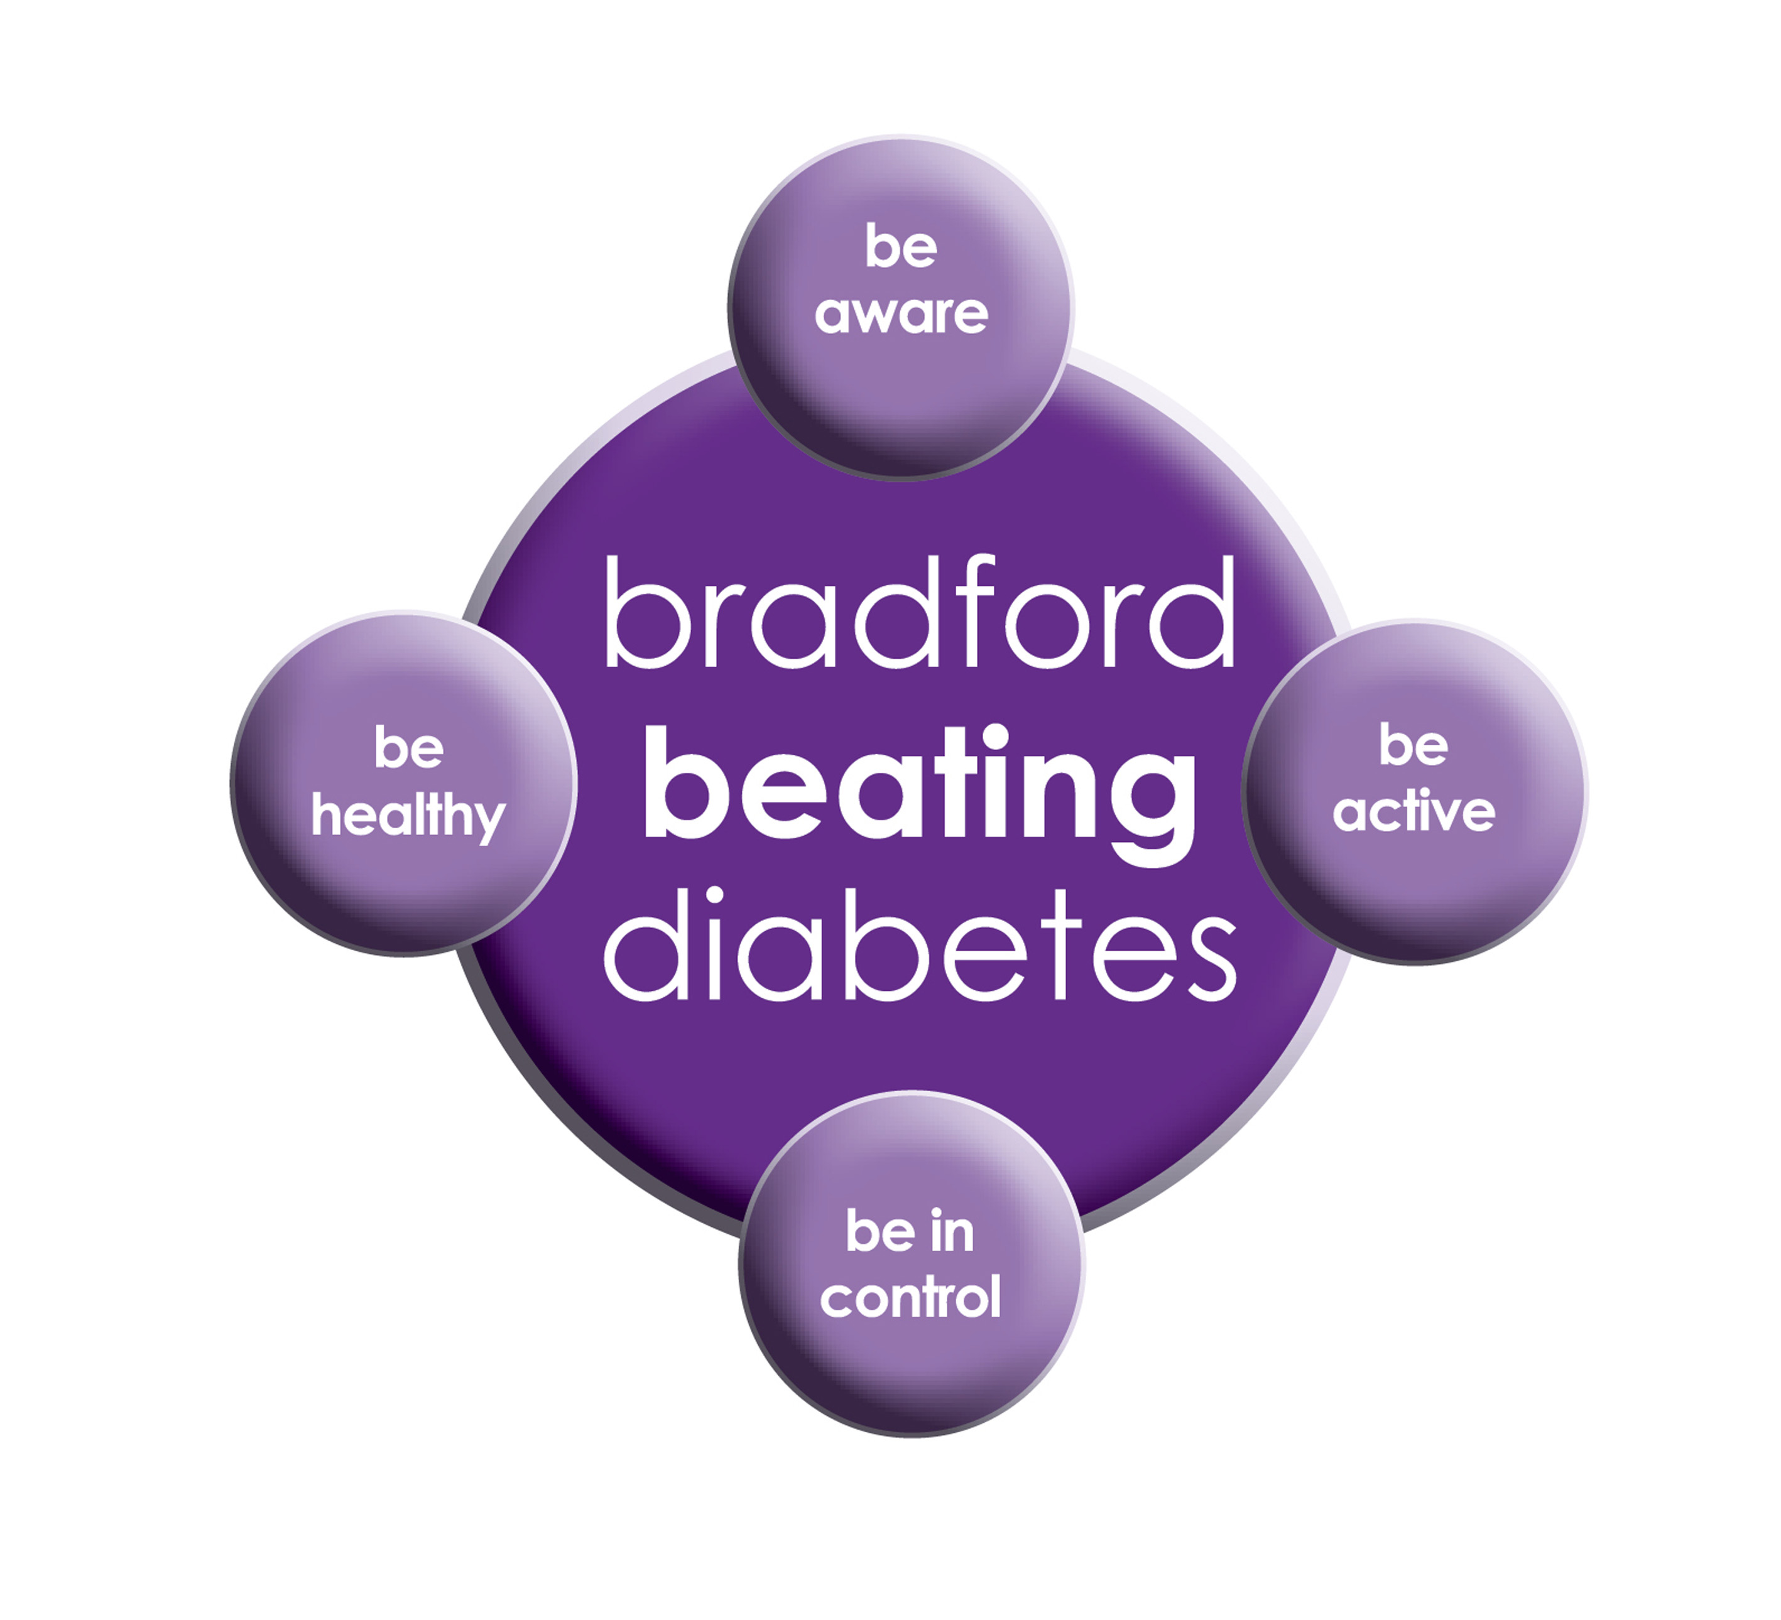

BRADFORD Beating Diabetes campaign is celebrating the success of its champions and patients who have been on the intensive lifestyle change programme.

In the 16 months since the campaign started, there have been about 1,000 newly-diagnosed patients in the city and a further 10,000 patients have received a brief lifestyle intervention from their family doctor.

The practice is inviting all adults aged over 25 (if they are from South Asian and certain other BME groups) or if they are aged over 40 (and white) and any others with conditions known to increase their risk of developing diabetes.

Some people are more at risk of developing diabetes than others:

- Those that have a family history of diabetes

- People who are overweight or have a large waist size

- People who are not physically active

- People who are south Asian or African Caribbean

**Please book an appointment if you think you are at risk of being diabetic.**

**Breast Screening**

Women between the ages of 50 and 70 are now routinely invited for free **screening** every three years. **The team are sending free screening invites for the surgery patients**. Please attend these appointments they are very important. **Screening** is for all well women without symptoms, whether they have a family history of **breast** cancer or not. Women over 70 are encouraged to make their own appointments.

**Up to date Telephone numbers**

**01274 957908 :Grange Medical**

**01274 957909 :Oaklane surgery**

**Dates our Surgeries are closed:**

Please note that the surgeries will be CLOSED on:

**Monday 26th August 2019 (bank holiday)**

Please contact Out Of Hours for any emergencies during those times on **NHS 111**

**Did Not Attend Policy:**

When a patient fails to attend an appointment *with a healthcare professional at the surgery a note of the date and time is made in their record. They are now sent a letter, If a patient fails to attend 2 appointments with a healthcare professional within a 3 month period, the patient will then receive another letter reminding them of the importance of cancelling an unwanted appointment.*

*If following this, the patient fails to attend another appointment, the Practice Manager will write to the patient informing them that they are at risk of being taken of the list, if the patient isn’t able to provide a valid explanation.*

*In the last month we have had a total of* ***163*** *patients DNA(did not attend) appointments. These appointments could have been used by patients who required medical attention. If you do need an appointment please remember to cancel the appointment,* ***please give at least 24 hours’ notice****.*

**To cancel appointments please call:**

**01274 957908 (Grange Medical)**

**01274 957909 (Oaklane surgery)**

**The surgery GPS and Staff would like to wish our patients EID MUBARAK for August**

**Warmer weather is good and makes you feel good, but it also brings a number of health risks too. The following advice will help you enjoy your summer safely.**

**• Stay out of the sun between 11am and 3pm especially when you are in holiday**

**• If you have to go out in the heat, shade, apply sunscreen and wear a hat.**

**• Have plenty of cold drinks, and avoid excess alcohol, caffeine and hot drinks.**

**Carers resource and VCS Organisations**

A carer is someone who provides help and support to a friend, neighbour or relative who could not manage otherwise because of frailty, illness or disability. They may even be juggling paid work with caring responsibilities at home. Carers have a tough job – it can mean unrelenting pressure, little chance to relax and a lot of worry. The system is complicated, and the issue is hidden.

The Carers’ Resource provides support for carers, no matter what their age, race, religion or needs.. If you would like more information please contact the carer’s resource on: **01274 449660. If you are a carer please notify your surgery we can code it on your record. There are also some blue cards which you fill in and send to the carers team.**

**REPEAT PRESCRIPTIONS**

This is a kind reminder for the patients regarding repeat prescriptions. GP practices can no longer accept repeat prescription requests from pharmacies.

You (or your carer, nominated family member/friend) must order your repeat prescription from your GP practice. We are having patients ringing the surgery line, this causes delay answering **urgent calls** please put the request in the red box.

**FREE Text Reminders for your Appointments**

**Sign up NOW and give consent so that you can receive your FREE text reminder message. Consent Forms are available from Reception.**

**Please make sure we have an up to date mobile number.**

**Would you like to sign up for newsletters by email? If so, please let the Reception have your email address.**

**Community Centres**

***The local Community centres have events and different classes available for patients and advice. The classes involve Healthy lifestyle classes, Exercise classes, Healthy cooking and eating, sewing classes, swimming classes. They are very effective and low cost classes. If you are on any benefits they may be free.***

***Grange Interlink contact:***

***Tel: 01274 726612***

*Summerville Rd, Bradford BD7 1PX.*

*Opening Times: Mon- Fri 9am till 4pm*

***Khidmet Centre contact :***

***Tel: 01274 521792***

*36 Spencer Rd, Bradford BD7 2EU*

*Opening Times: Mon- Fri 9am till 5pm*

**Girlington Community Centre**:

**Tel: 01274 542454**

Girlington Rd, Bradford BD8 9NN

Opening [Hours](https://www.google.co.uk/search?q=girlington+community+centre+hours&sa=X&ved=0ahUKEwi9_qTjm4LYAhVIOJoKHcM0Bw4Q6BMIlwEwEQ): · [9am–5pm](javascript:void(0))

[](http://www.onemedicare-northstreet.co.uk/Images/CMS/Media/62-PP.jpg)

**PATIENT PARTICIPATION**

**Here at Grange Medical Centre and at Oaklane Surgery we are always keen to hear what you think about the level of care and services provided.**

**You can get involved in the work of the practice by: Joining our Patient Participation Group. Joining our Virtual Group and leaving your contact details with reception.**

**Contacting us via our practice web site at www.drirshadkhanandpartners.co.uk**

**Our Patient Participation Group meetings are held quarterly at Grange Medical Centre.**

**Any Queries contact Mrs Shamraz Akhtar our PPG Lead or email** [Shamraz.Akhtar@bradford.nhs.uk](mailto:Shamraz.Akhtar@bradford.nhs.uk)

**Tel:01274 957908**