**Newsletter**

**GRANGE MEDICAL CENTRE/OAKLANE SURGERY**

**PATIENT NEWSLENNTTER**

**Summer 2017 Issue**

**Changes to Access clinics & Extended clinics at Grange medical**

***From May 2017 the Open Access clinics will run on Mondays and Friday mornings @ 8.30 am onwards. The Extended Clinic will also run on Mondays and Friday evenings from 6.30 pm, this clinic is for working patients and students who can’t come to the surgery before 6.30pm.***

**Summer holiday advice !**  

If you are going on holiday to enjoy the sunshine we have a few tips for you…

**Immunisations** – if you require injections for your holiday destination, please book an appointment with a nurse **as soon as possible** prior to your travel date.

**Sunburn** –If possible use sun tan lotion. If you do get burnt have a cool shower or bath and apply a good quality after-sun, if you are seriously burnt seek medical attention.

**Water -**Make sure you drink plenty of water, fruit juices or ice pops so you don’t get dehydrated.

**Bites and stings** –if you do get bitten or stung, try to remove the sting if still left inside you with fingers or tweezers, wash the area with soap and water, put on a cold flannel and raise the area to avoid swelling, use an antihistamine cream or spray – avoid itching as this can cause infection.

**Up to date Telephone numbers**

**01274 957908 :Grange Medical**

**01274 957909 :Oaklane surgery**

* **Please update your mobile numbers so you can receive text reminders for your appointments.**
* **Please also sign on to online services; you will have access to more appointments.**

**Did Not Attend Policy:**

If a patient fails to attend a pre-booked appointment on one occasion, an informal warning letter will be sent to the patent. This letter will be printed by the Duty Receptionist and posted to the patient.

If the patient fails to attend another appointment within a 12 month period, a formal warning letter will be sent reminding them that should they miss another appointment they risk being removed from the practice list.

If the patient fails to attend 3 appointments within a 12 months period, this patient’s details will be brought to Dr Syed Abbas Zaidi’s attention by Ravinder Khan Practice Manager. Dr Syed Abbas Zaidi will make a decision as to whether the patient is removed from the list.

*In the last month we have had a total of* ***331*** *patients (did not attend) appointments. These appointments could have been used by patients who required medical attention. If you do need an appointment please remember to cancel the appointment,* ***please give at least 24 hours’ notice****.*

**To cancel appointments please call:**

**01274 957908 (Grange Medical)**

**01274 957909 (Oaklane surgery)**

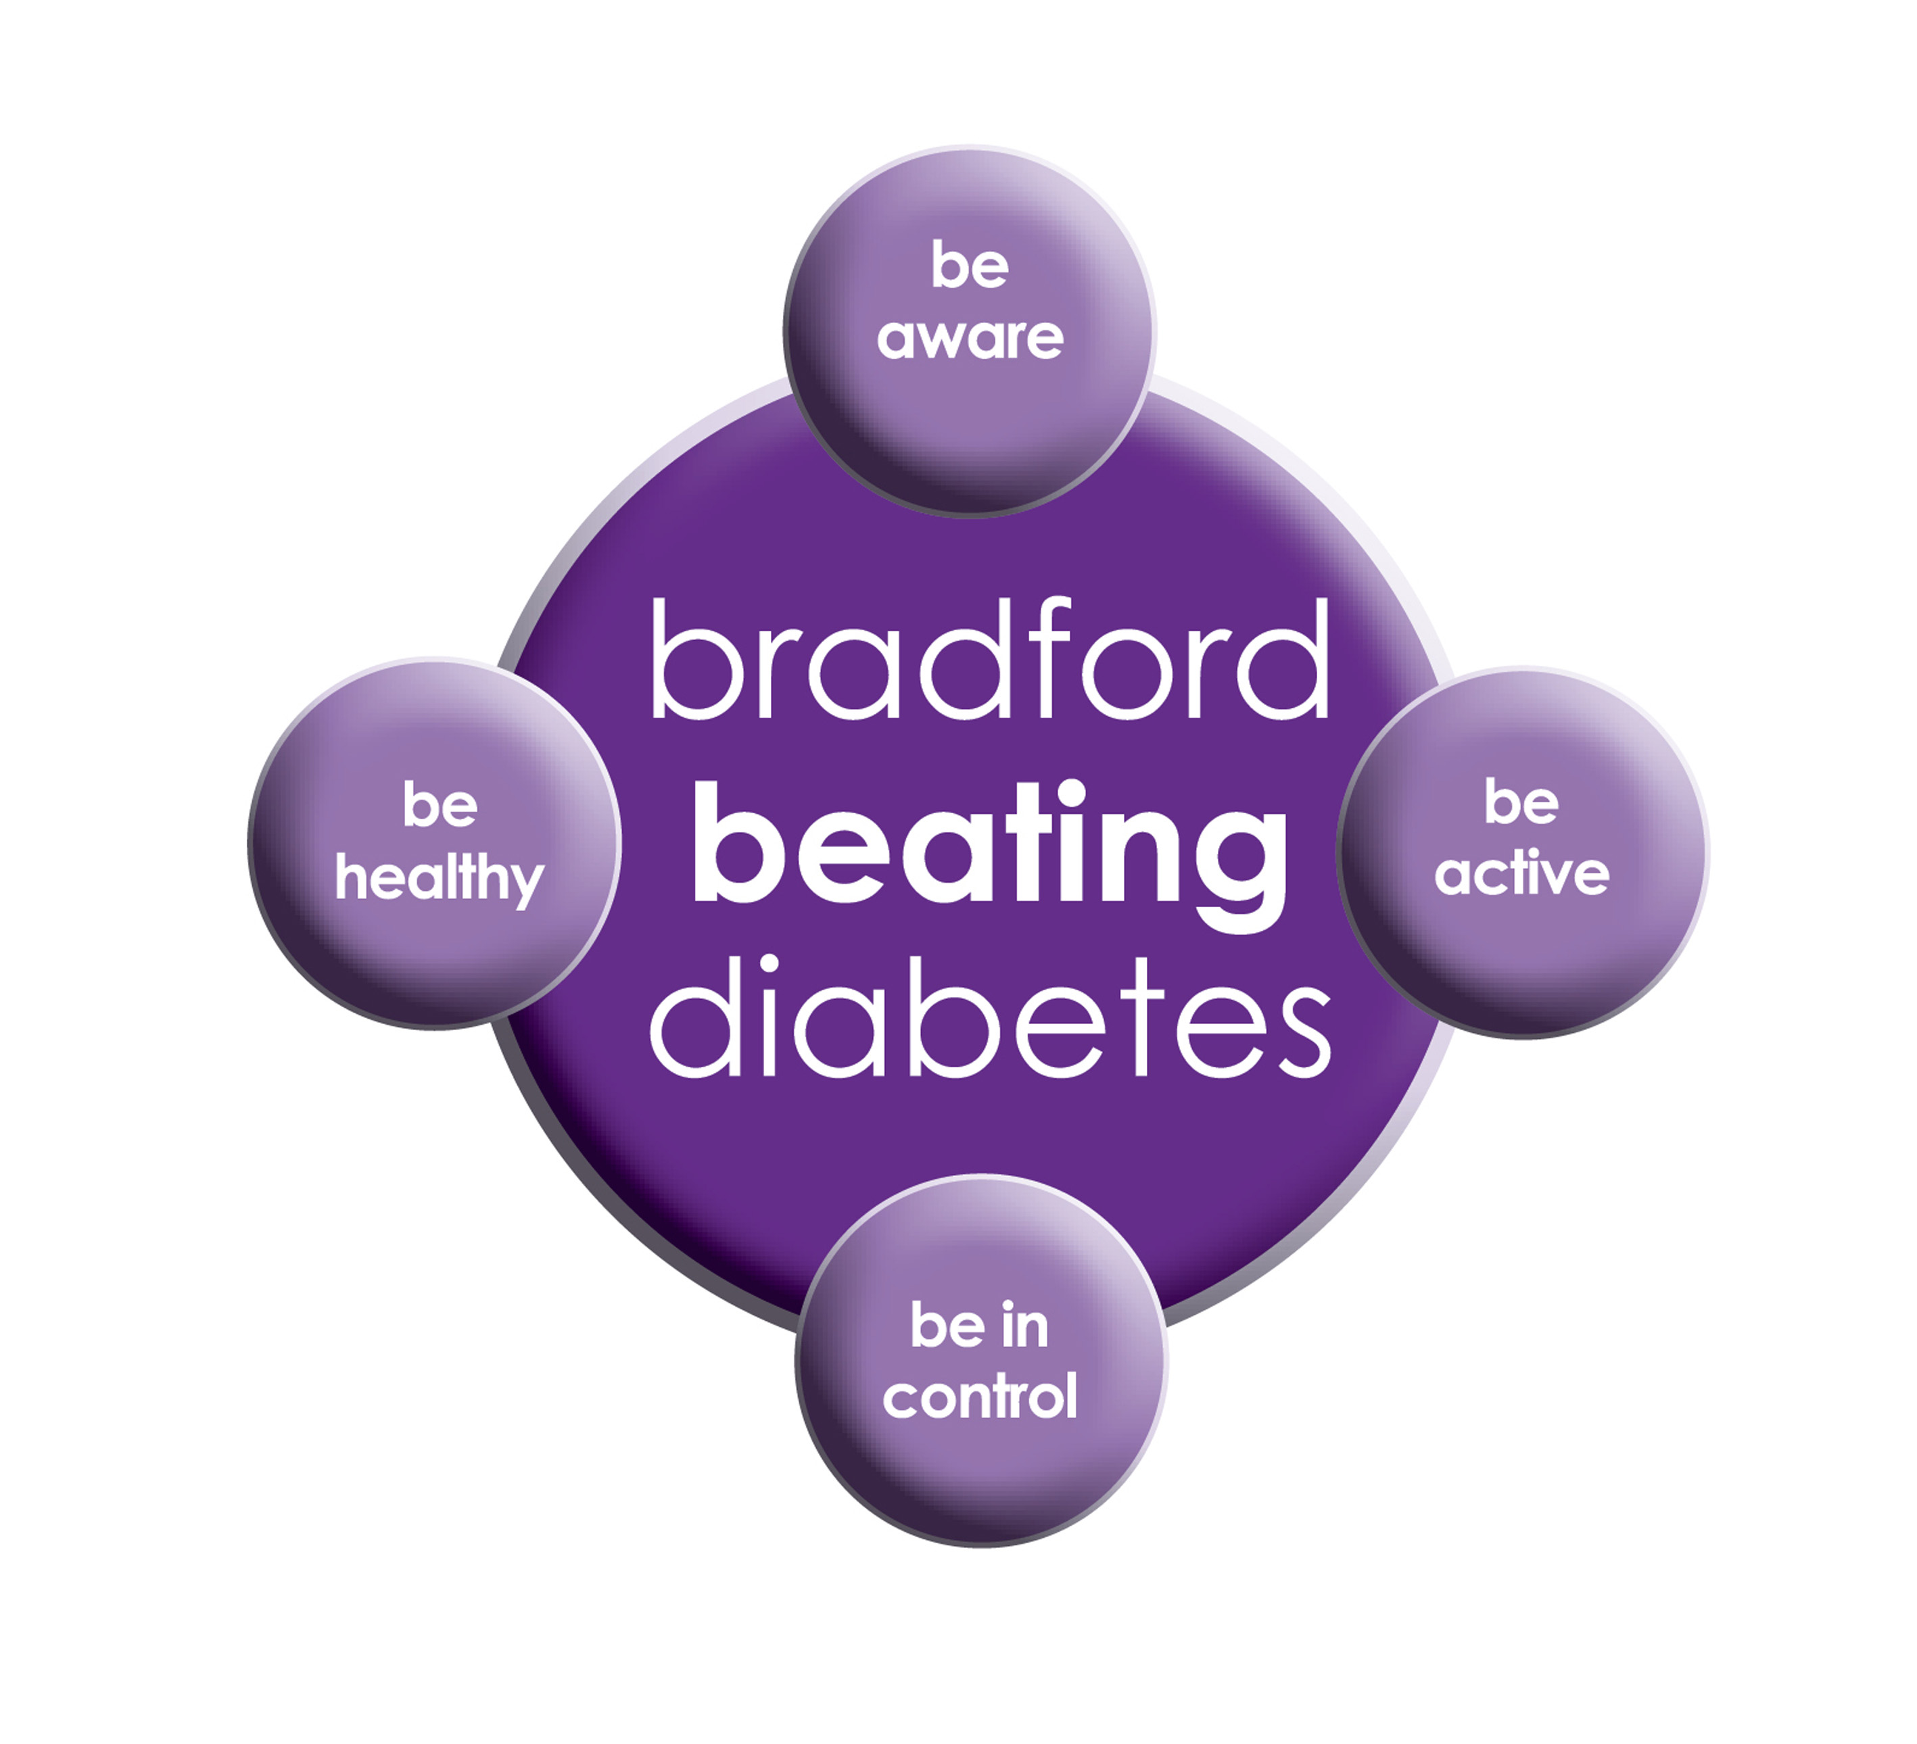

BRADFORD Beating Diabetes campaign is celebrating the success of its champions and patients who have been on the intensive lifestyle change programme.

In the 16 months since the campaign started, there have been about 1,000 newly-diagnosed patients in the city and a further 10,000 patients have received a brief lifestyle intervention from their family doctor.

The practice is inviting all adults aged over 25 (if they are from South Asian and certain other BME groups) or if they are aged over 40 (and white) and any others with conditions known to increase their risk of developing diabetes.

Some people are more at risk of developing diabetes than others:

- Those that have a family history of diabetes

- People who are overweight or have a large waist size

- People who are not physically active

- People who are south Asian or African Caribbean

**Please book an appointment if you think you are at risk of being diabetic.**

**Over the counter Medication**

There are many over-the-counter medications available without a prescription, which are used to treat the symptoms of many illnesses and don't usually require the help of a Doctor. You can buy medication for symptoms like:

* Minor aches and pains,
* [Fever](http://www.emedicinehealth.com/fever_in_adults/article_em.htm)
* [Diarrhea](http://www.emedicinehealth.com/diarrhea/article_em.htm),
* [Cold](http://www.emedicinehealth.com/colds/article_em.htm) symptoms,
* [Sore throat](http://www.emedicinehealth.com/sore_throat/article_em.htm)/coughs
* [Allergies](http://www.emedicinehealth.com/slideshow_10_common_allergy_triggers/article_em.htm).
* Constipation
* Hay fever
* Head lice
* Headache and fever
* Heartburn and indigestion
* Insect bites and stings

Pharmacists can also give you help and advice on other minor ailments.

**Repeat prescription changes**

The CCGs in Bradford have implemented a new scheme which means that pharmacies will no longer be able to order medicines on behalf of patients. This means that patients will need to order their repeat prescription directly from their GP practice.  The aim is to empower patients to have greater control and understanding of their medicines.

Patients can save time by ordering their repeat prescriptions securely online or by nominating a trusted family member/carer to do this on their behalf, if they wish. It also enables patients in Bradford to book their GP appointments online at any time.

[](http://www.google.co.uk/url?url=http://www.clipartpanda.com/categories/pharmacy-building-clipart&rct=j&frm=1&q=&esrc=s&sa=U&ved=0ahUKEwiZpoqBqYPVAhWII8AKHf1hBUMQwW4IHDAD&usg=AFQjCNF_SYIvpK98UK5c4FG4rLYMGwyyUA)

***National Survey Results***

*The national survey results were discussed in the practice meeting and Patient participation meeting in August 2017. The staff and PPG members made suggestions on how we could improve the results and uptake of the surveys for the future, because there weren’t many surveys sent back by the patients.*

*The overall survey result was low. We would like suggestions from our patients. This is your surgery, if you think we need to make any improvements please give us feedback. You can leave feedback with the Practice manager’s, GPs attention or with the supervisors or staff.*

***The practice would like to thank the patients who took their time out and replied to the surveys.***

***If you receive any surveys in the future please full them in and send them back. If you are unsure of anything please ask the staff at the surgery.***

**Carers resource and VCS Organisations**

A carer is someone who, without payment, provides help and support to a friend, neighbour or relative who could not manage otherwise because of frailty, illness or disability. They may even be juggling paid work with caring responsibilities at home. Carers have a tough job – it can mean unrelenting pressure, little chance to relax and a lot of worry. The system is complicated, and the issue is hidden.

The Carers’ Resource provides support for carers, no matter what their age, race, religion or needs. Follow the links on the carer’s resource website to discover what support can be offered to you as a carer, or as someone who might work with carers. At the practice we have a notice board for patients with updates and contact details if you need to get in touch with the organisation. The patients, who attend, find this service really helpful. If you would like more information please contact the carer’s resource on: **01274 449660. If you are a carer please notify your surgery we can code it on your record.**

**FRIENDS AND FAMILY TEST , NATIONAL SURVEYS & FEEDBACK FORMS**

**We would like to know how likely you are to recommend our practice to friends and family if they needed treatment. Please fill in the questionnaires on the reception desk or online.**

**We will also be handing out our questionnaires for 2017, please take a few minutes of your time to fill in the questionnaires. This will help the practice to improve in any areas needed. It will also give us an idea about what our patients think of the practice.**

**Advisory Service**

We have an advisor who comes in once a week. She helps patients with benefits and housing advice.

She can help reading important letters and filling in forms. You do not need a Doctor’s appointment to get forms filled in the advisor may be able to do that for you if needed. If you wish to make an appointment, please contact the surgery.

**Community Centres**

***The local Community centres have events and different classes available for patients and advice. The classes involve Healthy lifestyle classes, Exercise classes, Healthy cooking and eating, sewing classes, swimming classes. They are very effective and low cost classes. If you are on any benefits they may be free.***

***Grange Interlink contact: 01274 726612***

***Khidmet Centre contact : 01274 521792***

***Girlington Community Centre: 01274 542454***

**FREE Text Reminders for your Appointments**

**Sign up NOW and give consent so that you can receive your FREE text reminder message. Consent Forms are available from Reception.**

**If you don’t attend appointments you may be taken of the list.**

[](http://www.onemedicare-northstreet.co.uk/Images/CMS/Media/62-PP.jpg)

**PATIENT PARTICIPATION**

**Here at Grange Medical Centre and at Oaklane Surgery we are always keen to hear what you think about the level of care and services provided.**

**You can get involved in the work of the practice by: Joining our Patient Participation Group.**

**Joining our Virtual Group and leaving your contact details with reception.**

**Contacting us via our practice web site at www.drirshadkhanandpartners.co.uk**

**Our Patient Participation Group meetings are held quarterly at Grange Medical Centre.**

**Any Queries contact Mrs Shamraz Akhtar our PPG Lead or email** [**Shamraz.Akhtar@bradford.nhs.uk**](mailto:Shamraz.Akhtar@bradford.nhs.uk)

**We would like to welcome our new staff and apprentices**