*needed. Thank you for your time and effort.*

**Newsletter**

**GRANGE MEDICAL CENTRE/OAKLANE SURGERY**

**PATIENT NEWSLETTER**

**Summer 2018 Issue**

**What’s new in the practice:**

**Grange Medical Centre/ Oaklane surgery**

**CQC overall rating: GOOD !!!**

The Care Quality Commission (CQC) inspected the Surgeries in April 2018 and we were very pleased that the Surgery was rated as ***GOOD***. You can see a full copy of their report on our website.

***We would like to thank our patients and PPG members for all their help and support.***

***Healthy living advice***

***Walking is the perfect activity for health!!!***

***Did you know? Walking can...***

***• Make you feel good***

***• Give you more energy***

***• Help you sleep better***

***• Help you reduce stress***

***• Keep your heart ‘strong’***

***• Reduce blood pressure***

***\* Help to manage your weight***

**Remember to…Think Speak to the Pharmacy** to get advice and medicines to treat common illnesses, such as coughs, colds, upset stomachs and skin problems. All pharmacies are more than happy to give advice and give **Over the counter Medication** if needed.

**Bowel Screening**

The bowel cancer screening test for people aged 60 or over is a kit you use at home.

This is used to check for tiny amounts of blood in your poo. It doesn't diagnose bowel cancer, but it's a simple way to find out if you need further tests.

It's also called the faecal occult blood (FOB) test.

If you have not sent specimen bottle, please send this next time

All men and women aged 60 to 74 who are registered with a GP in England are automatically sent a bowel cancer screening kit every 2 years.

***If you're 75 or over, you can ask for a kit every 2 years by phoning the free bowel cancer screening helpline on 0800 707 60 60.***

**Cervical cancer**

Cervical cancer is the most common cancer in women under 35 in the UK, but can affect women of any age. Cervical cancer is one of the most preventable cancer types.

Screening, vaccination and lifestyle can all play a role. Cervical screening saves up to 5,000 lives from cervical cancer every year in the UK. Women aged 25-49 are invited for screening every 3 years. Women aged 50-64 are invited every 5 years.

If you have any questions about cancer – cancer research UK can help:

ASK their specialist information nurses on

**0808 800 4040.**

**New Staff**

Since the last newsletter we are delighted to have welcomed our new member of the team,

* Hafsa Begum our new practice Nurse

**Hay fever treatment**

There’s currently no cure for hay fever, but most people are able to relieve symptoms with treatment, at least to a certain extent.

Treatment options for hay fever include antihistamines, which can help to prevent an allergic reaction from occurring and corticosteroids (steroids), which help to reduce inflammation and swelling.

Hay fever can often be controlled using over-the-counter medication from your pharmacist. However, if your symptoms are more troublesome it’s worth speaking to your GP, as you may require prescription medication.

[](https://www.google.co.uk/imgres?imgurl=https%3A%2F%2Fwww.nasalguard.co.uk%2Fv%2Fvspfiles%2Fassets%2Fimages%2FHay-Fever.jpg&imgrefurl=https%3A%2F%2Fwww.nasalguard.co.uk%2FHay_Fever_Relief_a%2F271.htm&docid=BseGvY4eTKlDzM&tbnid=IF8q8utG4ywDxM%3A&vet=10ahUKEwi889Kt2YDcAhVJ3KQKHa8mAjUQMwjsASgUMBQ..i&w=490&h=490&bih=651&biw=1024&q=hayfever&ved=0ahUKEwi889Kt2YDcAhVJ3KQKHa8mAjUQMwjsASgUMBQ&iact=mrc&uact=8)

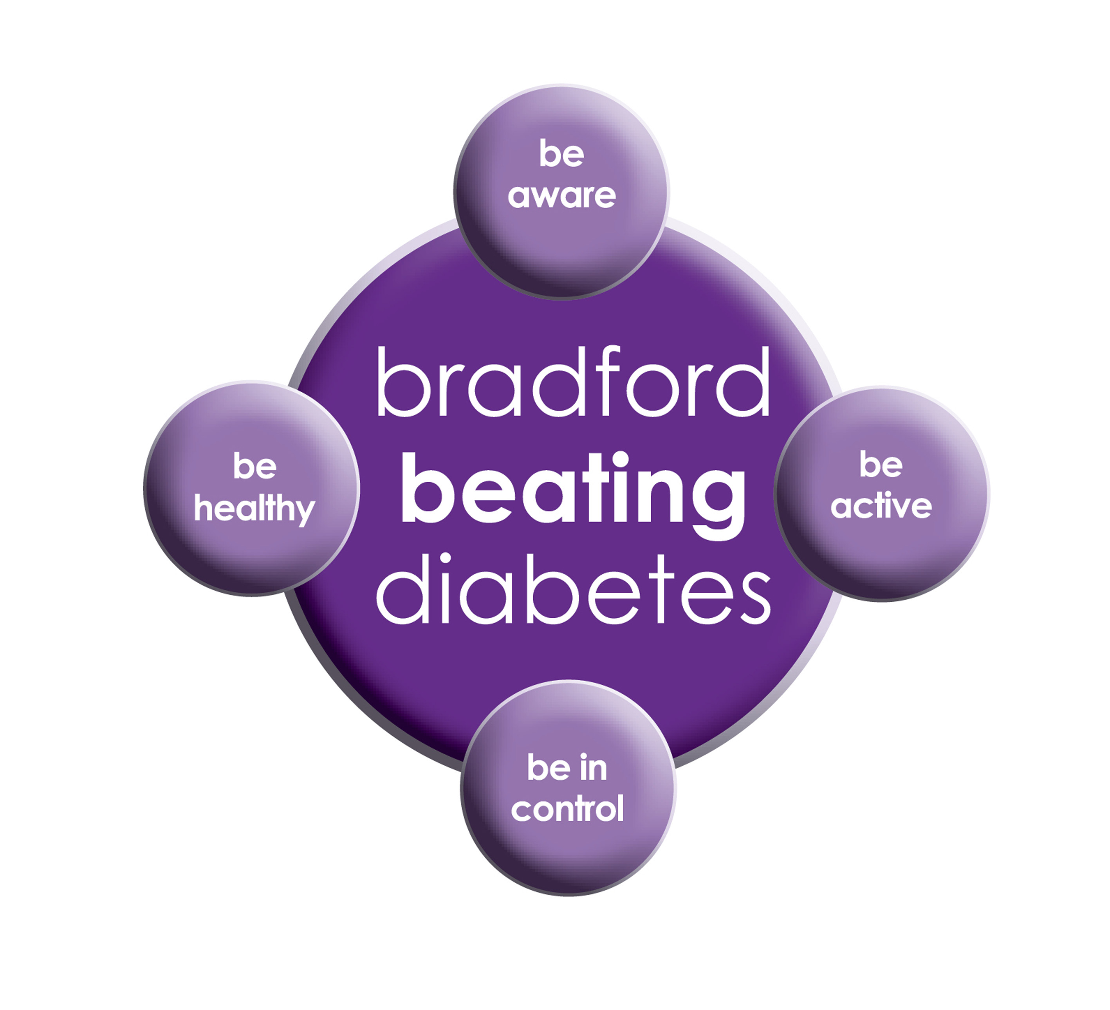

BRADFORD Beating Diabetes campaign is celebrating the success of its champions and patients who have been on the intensive lifestyle change programme.

In the 16 months since the campaign started, there have been about 1,000 newly-diagnosed patients in the city and a further 10,000 patients have received a brief lifestyle intervention from their family doctor.

The practice is inviting all adults aged over 25 (if they are from South Asian and certain other BME groups) or if they are aged over 40 (and white) and any others with conditions known to increase their risk of developing diabetes.

Some people are more at risk of developing diabetes than others:

- Those that have a family history of diabetes

- People who are overweight or have a large waist size

- People who are not physically active

- People who are south Asian or African Caribbean

**Please book an appointment if you think you are at risk of being diabetic.**

[](https://www.google.co.uk/imgres?imgurl=https%3A%2F%2Fsporto.in%2Fpub%2Fmedia%2Fwysiwyg%2F3_1.jpg&imgrefurl=https%3A%2F%2Fsporto.in%2Fblog%2F6-ways-to-stay-active%2F&docid=0bMsAwcdWB6jsM&tbnid=79Gwku08bMvftM%3A&vet=10ahUKEwjU1vrWwYLcAhXBxxQKHRlTC5oQMwhlKCgwKA..i&w=236&h=360&bih=651&biw=1024&q=staying%20active&ved=0ahUKEwjU1vrWwYLcAhXBxxQKHRlTC5oQMwhlKCgwKA&iact=mrc&uact=8)

**Up to date Telephone numbers**

**01274 957908 :Grange Medical**

**01274 957909 :Oaklane surgery**

* **Please update your mobile numbers so you can receive text reminders for your appointments.**
* **Please also sign on to online services; you will have access to more appointments.**

**Dates our Surgeries are closed:**

Please note that the surgeries will be CLOSED on:

**MONDAY 27 August 2018 (Bank Holiday)**

Please contact Out Of Hours for any emergencies during those times on **NHS 111**

**Did Not Attend Policy:**

When a patient fails to attend an appointment *with a healthcare professional at the surgery a note of the date and time is made in their record. They are now sent a letter, If a patient fails to attend 2 appointments with a healthcare professional within a 3 month period, the patient will then receive another letter reminding them of the importance of cancelling an unwanted appointment.*

*If following this, the patient fails to attend another appointment, the Practice Manager will write to the patient informing them that they are at risk of being taken of the list, if the patient isn’t able to provide a valid explanation.*

*In the last month we have had a total of* ***160*** *patients DNA(did not attend) appointments. These appointments could have been used by patients who required medical attention. If you do need an appointment please remember to cancel the appointment,* ***please give at least 24 hours’ notice****.*

**To cancel appointments please call:**

**01274 957908 (Grange Medical)**

**01274 957909 (Oaklane surgery)**

**Advisory Service**

We have an advisor who comes in once a week.

She helps patients with benefits and housing advice.

She can help with reading important letters and filling in forms. You do not need a Doctor’s appointment to get forms filled in, the advisor may be able to do that for you if needed. If you wish to make an appointment, please contact the surgery.

**Carers resource and VCS Organisations**

A carer is someone who provides help and support to a friend, neighbour or relative who could not manage otherwise because of frailty, illness or disability. They may even be juggling paid work with caring responsibilities at home. Carers have a tough job – it can mean unrelenting pressure, little chance to relax and a lot of worry. The system is complicated, and the issue is hidden.

The Carers’ Resource provides support for carers, no matter what their age, race, religion or needs. Follow the links on the carer’s resource website to discover what support can be offered to you as a carer, or as someone who might work with carers. At the practice we have a notice board for patients with updates and contact details if you need to get in touch with the organisation. The patients, who attend, find this service really helpful. If you would like more information please contact the carer’s resource on: **01274 449660. If you are a carer please notify your surgery we can code it on your record. There are also some blue cards which you fill in and send to the carers team.**

**FREE Text Reminders for your Appointments**

**Sign up NOW and give consent so that you can receive your FREE text reminder message. Consent Forms are available from Reception.**

**Please make sure we have an up to date mobile number.**

**Would you like to sign up for newsletters by email? If so, please let the Reception have your email address.**

[](http://www.onemedicare-northstreet.co.uk/Images/CMS/Media/62-PP.jpg)

**PATIENT PARTICIPATION**

**Here at Grange Medical Centre and at Oaklane Surgery we are always keen to hear what you think about the level of care and services provided.**

**You can get involved in the work of the practice by: Joining our Patient Participation Group. Joining our Virtual Group and leaving your contact details with reception.**

**Contacting us via our practice web site at www.drirshadkhanandpartners.co.uk**

**Our Patient Participation Group meetings are held quarterly at Grange Medical Centre.**

**Any Queries contact Mrs Shamraz Akhtar our PPG Lead or email** [Shamraz.Akhtar@bradford.nhs.uk](mailto:Shamraz.Akhtar@bradford.nhs.uk)

**Tel:01274 957908**

**Community Centres**

***The local Community centres have events and different classes available for patients and advice. The classes involve Healthy lifestyle classes, Exercise classes, Healthy cooking and eating, sewing classes, swimming classes. They are very effective and low cost classes. If you are on any benefits they may be free.***

***Grange Interlink contact:***

***Tel: 01274 726612***

*Summerville Rd, Bradford BD7 1PX.*

*Opening Times: Mon- Fri 9am till 4pm*

***Khidmet Centre contact :***

***Tel: 01274 521792***

*36 Spencer Rd, Bradford BD7 2EU*

*Opening Times: Mon- Fri 9am till 5pm*

**Girlington Community Centre**:

**Tel: 01274 542454**

Girlington Rd, Bradford BD8 9NN

Opening [Hours](https://www.google.co.uk/search?q=girlington+community+centre+hours&sa=X&ved=0ahUKEwi9_qTjm4LYAhVIOJoKHcM0Bw4Q6BMIlwEwEQ): · [9am–5pm](javascript:void(0))