**Newsletter**

**GRANGE MEDICAL CENTRE/OAKLANE SURGERY**

**PATIENT NEWSLENNTTER**

**September 2016 Issue**

**Up to date Telephone numbers**

**01274 957908 Grange Medical**

**01274 957909 Oaklane surgery**

* **Please update your mobile numbers so you can receive text reminders for your appointments.**
* **Please also sign on to online services; you will have access to more appointments.**

**Grange Medical Centre was Awarded Patient Group of 2016**

**by Bradford CCG**

**We would like to Thank all our patients and PPG Members who have helped.**

**Comments from the CCG:**

*This year, one group has stood out for their approach to self-care initiatives, events in the community, involving and reaching people and building a solid patient group. The patient participation members at* ***Grange Medical Practice*** *are described as “very helpful, enthusiastic and very supportive in all ways”. They have supported the development of the practices access plans and are available to help and give new ideas. They are willing to participate in the events that take place in the surgery and attend the PPG meetings. They are an asset to the practice and an example of how good engagement can build a stronger practice.*

[](http://www.google.co.uk/url?url=http://pcdblog.com/2015/02/you-can-still-and-should-get-a-flu-shot-by-our-february-student-pharmacist-ashley-sullivan/&rct=j&frm=1&q=&esrc=s&sa=U&ved=0CC4QwW4wDDgUahUKEwjO_cqDx63IAhWKuBQKHSISCUE&usg=AFQjCNH5JiAMx5ed5xJzL8BNdtH5jEiktQ)

**Flu Vaccines 2016**

**Anyone in these risk groups is more likely to develop potentially serious** [**complications of flu**](http://www.nhs.uk/Conditions/Flu/Pages/Complications.aspx)**, such as**[**pneumonia**](http://www.nhs.uk/conditions/Pneumonia/Pages/Introduction.aspx) **(a lung infection), so it's recommended that they have a flu vaccine every year to protect them.**

**At risk group include:**

* **All over 65**
* **Any age with certain long term conditions such as Asthma/COPD, heart problems or past stroke and diabetes**
* **Pregnancy at any stage**
* **If you are a carer**

**The flu vaccine is also given on the NHS as an annual** [**nasal spray**](http://www.nhs.uk/Conditions/vaccinations/Pages/child-flu-vaccine.aspx) **to:**

**Healthy children aged two, three and four years old plus children in school years one and two and children aged two to 17 years at a particular risk of flu.**

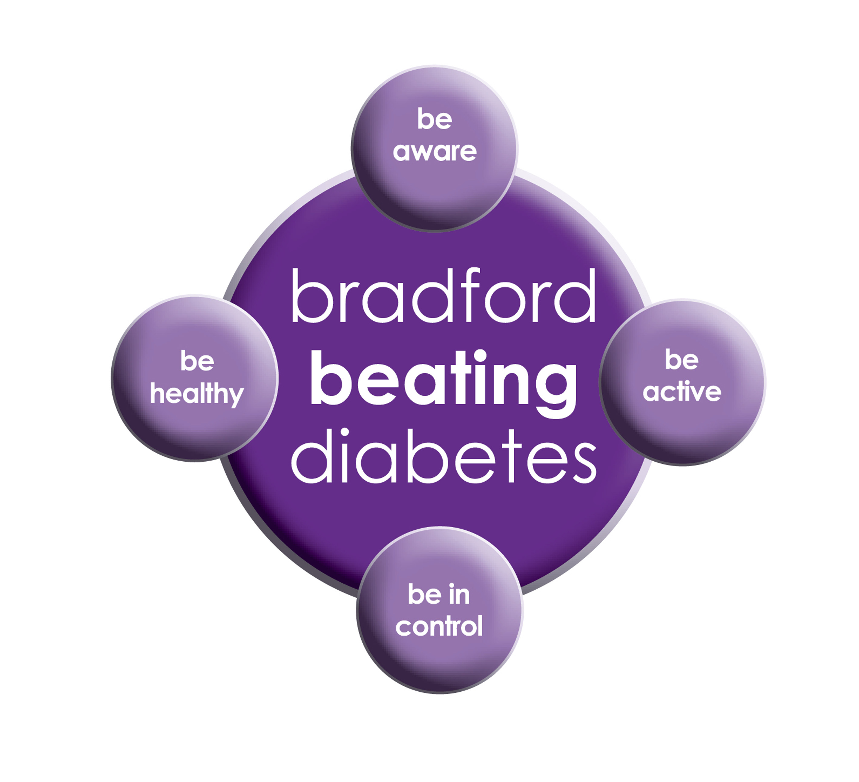

BRADFORD Beating Diabetes campaign is celebrating the success of its champions and patients who have been on the intensive lifestyle change programme.

In the 16 months since the campaign started, there have been about 1,000 newly-diagnosed patients in the city and a further 10,000 patients have received a brief lifestyle intervention from their family doctor.

The practice is inviting all adults aged over 25 (if they are from South Asian and certain other BME groups) or if they are aged over 40 (and white) and any others with conditions known to increase their risk of developing diabetes.

Some people are more at risk of developing diabetes than others:

- Those that have a family history of diabetes

- People who are overweight or have a large waist size

- People who are not physically active

- People who are south Asian or African Caribbean

**Please book an appointment if you think you are at risk of being diabetic.**



**Pharmacy First**

**Patients can go straight to the pharmacy for minor ailments for advice and treatment.**

**You can go to the pharmacy for the following ailments:**

**\*Cold *Sore throat**

**\*Athletes foot *Fever *Earache**

**\*Thrush *Teething *Threadworms**

**\*Blocked Nose *Hay fever**

**Children and Young Adults Event**

We are happy to announce that the Children and Young Adults Event that took place on the 28/07/2016 ran very successfully. We would like to thank the Age Uk Organisation, Cancer Research Team, ABL, Self Care Team, Book Start, and Lynfield Mount Library, Grange Interlink for taking part and for the useful resources provided. We would also like to thank our PPG Members and patients for participating in the event. We will hopefully be organising another event in July 2017.  We will post the date online.

If you have any suggestions and if you would like to see any different organisations, we will try to organise this.  Please contact myself Shamraz Akhtar (PPG Lead) or Ravinder Khan at Grange Medical on 01274 957908.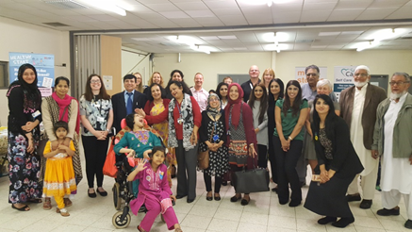

**FRIENDS AND FAMILY TEST , NATIONAL SURVEYS & FEEDBACK FORMS**

**We would like to know how likely you are to recommend our practice to friends and family if they needed treatment. Please fill in the questionnaires on the reception desk or online.**

**We will also be handing out our questionnaires for 2016/2017, please take a few minutes of your time to fill in the questionnaires. This will help the practice to improve in any areas needed. It will also give us an idea about what our patients think of the practice.**

**If you are sent any national surveys please do fill them in, if you need any help please come to the surgery our staff members will be more than happy to assist you.**

[](http://www.onemedicare-northstreet.co.uk/Images/CMS/Media/62-PP.jpg)

**PATIENT PARTICIPATION**

**Here at Grange Medical Centre and at Oaklane Surgery we are always keen to hear what you think about the level of care and services provided.**

**You can get involved in the work of the practice by: Joining our Patient Participation Group.**

**Joining our Virtual Group and leaving your contact details with reception.**

**Contacting us via our practice web site at** [**www.drirshadkhanandpartners.co.uk**](http://www.drirshadkhanandpartners.co.uk)

**Our Patient Participation Group meetings are held quarterly at Grange Medical Centre.**

**Any Queries contact Mrs Shamraz Akhtar our PPG Lead or email** [**Shamraz.Akhtar@bradford.nhs.uk**](mailto:Shamraz.Akhtar@bradford.nhs.uk)

**FREE Text Reminders for your Appointments**

**Sign up NOW and give consent so that you can receive your FREE text reminder message. Consent Forms are available from Reception.**

**If you don’t attend appointments you may be taken of the list.**

**Good News For Our Patients**

We have more appointments available to

book seven days in advance, two days in

advance and on the day. This was suggested

by our patients and PPG members.

We appreciate your valuable suggestions.

**We would like to welcome our new staff Alyssa Khan**