Messages for social media/practice websites

It is recognised that safeguarding issues and other illnesses will continue to develop during the COVID-19 pandemic. They will become potentially more covert, trickier to identify and manage. The incidence and threat of Domestic Violence (and other forms of abuse) is likely to escalate with so many families in a state of lockdown, isolation and facing financial constraints.

Please find below some content that could be included on your practice website/social media platforms in order to provide further information to the following vulnerable groups:

- Adolescents
- Families
- Domestic abuse – victims and perpetrators

The adolescent and family content has been adapted from template letters provided by Dr Richard Burack, Co-Author: Ms Megan Burack; in collaboration with the executive members of the PCSF, RNNNGP and the Royal College of General Practitioners (RCGP) Adolescent Working Group (AWG).

Covid-19 information for 13- 19 year olds
As a practice, we wanted to let you know that we are still here, able and willing to support you and provide services for your on-going or developing medical needs.

We are also able to still see you face to face but only if this is essential. Currently, we will need to speak / video consult with you first as the best way to keep you safe and maintain your health.

We would also like to provide you with some additional information by answering some questions from young people on their healthcare and about COVID-19. We hope that our answers may help you cope with the restrictions that lockdown or self-isolation may have on your overall well-being.

Q1. Is it OK to be worried about what’s happening?

These are truly extra-ordinary times where information and issues are changing extremely rapidly. It is not surprising that each day can feel totally different to the next and this is unsettling. What’s happening in the world right now can feel daunting, unable to make plans even for the immediate future - it’s very normal to feel anxious and unsure about things.

Maybe your exams have been cancelled, or your first year at university has come to a sudden halt, or school has been closed for the foreseeable future? Whether you’re feeling overwhelmed, unproductive, anxious or hopeless, your feelings are justified – you are not alone in feeling this way.

Q2. Can I call to speak to a doctor if I am worried about my health?

If you are feeling very overwhelmed and are struggling to function normally, there is help available. Please contact us – we are still here to help. Calls may take a little longer to answer on our switchboard but we will endeavour to manage and direct your call to the most appropriate person to help with your medical query / need. {Call us on 01274 957908 - Grange MC / 01274 957909 – Oaklane Surgery}

Q3. Will any contact I make be confidential?

As a registered patient of ours, you are entitled to receive medical support, care and assistance from our staff. You do not need permission from your parents or guardian to make an appointment or chat to one of our doctors or nurses. Please be reassured that contact and discussions with any of our staff is treated with confidence, as will the opportunity to speak or consult with one of our clinical staff.

Q4. I have read that I could e-mail the doctor with a question, is this possible?

As of 1 April 2020 we are operating ‘e-consult.’ This means you can send us a question or concern and we will get back to you, on the same day, with a response. This is new for us and you will need to register to be able to use the service. If you are under 16, your parents will need to register on your behalf, but then you will be able to send a request yourself, and receive a reply back to your given e-mail.

Q5. Will you have a record of my mobile or e-mail address if you need to contact me?

With the increased role of technology in all we do now, it is very important that we have a current mobile and e-mail address for you, so that, with your permission, we can text or contact you directly. We may have an old contact or a parent’s mobile number attached to your records so to update your details would help us ensure we can keep in contact with you appropriately and directly when you need advice or support.

Could you e-mail the practice {b83034.grangemc@nhs.net} with your current contact details and giving your consent (permission) for us to be able to contact you by this means if you are happy for us to do so. Our staff will then update your records.

Q6. I am a young carer, should I let you know about this?

Absolutely - yes please. Whether you have been a carer of others in your family for a while or just recently because of COVID-19 please contact the surgery so we can make a note of this. If you are struggling or having difficulties with your caring responsibilities or if you have any questions, we would be happy to try and help.

Q7. Social Media is giving me mixed messages and confusing me, how do I know what is true and what is false?

Sometimes feeling stressed or anxious can be related to seeing lots of media coverage and new stories about the impact of COVID-19. At the moment, there is a lot of coverage from all media and although it is important to stay informed, consider taking a break from social media if you feel things are getting on top of you.

However some days, social media might be your only source of news and information. While some of what you read is trustworthy, a lot of it isn’t, and it’s put out there to scare and confuse you. Consuming so much of this information at once can make you feel more anxious and it’s important to know when to give yourself a break from it. Social media can also be fantastic, try to use it for positive and upbeat interactions with friends and family.

Q8. So where should I get my advice and information about COVID-19?

Only take advice from trusted government and health service websites such as GOV.uk or nhs.uk. These have all the latest facts and figures to give consistent advice on how to prevent spreading, catching it and what to do if you think you have coronavirus.

Q9. How can I occupy myself to avoid boredom and feeling even worse about things?

Despite the loss of normal routine and activities, try to develop and implement a new routine that provides a balance of several different activities and interactions with others. At times like these, it can be easy to fall into unhealthy patterns of behaviour, which can make you feel worse.

Simple things you can do to stay mentally and physically active during this time include:

- Wake up relatively early – (annoying but it does help). Lying in bed until early afternoon will drain your energy levels and crush productivity. Set a nice alarm to wake up to and allow yourself more time to get ready and start the day properly.
- Stay connected to your friends and family via skype, email, video-calling and telephone / texting. Don’t rely just on texting though, as an audio-visual catch up is much more rewarding.
- Social media can be an excellent way to keep in touch with your friends and family. However, you should be mindful of your use of social media. Use it to promote positive interactions, and put your device away if it starts to negatively affect your mood. Many smartphones allow you to set time limits for certain apps such as Instagram.
- It is important to maintain, where possible, some sort of daily routine. You should vary what you put into your routine to keep things different and interesting but try and include key elements consistently.
- Make a to-do list (or schedule / rota) with reasonable and specific things included. Finalise your schedule / rota the night before so you are ready and prepared for the day ahead. Include spending time doing things you enjoy as well as things you need to do:
  - Time to eat (breakfast, lunch and dinner)
  - Time to network chat and socialise, social media / gaming (IT based)
  - Time to do work, study, homework, coursework, learn, research
  - Time for exercise
  - Time for relaxing, personal downtime (non IT based)
  - Time to spend with family
  - Time to spend doing something fun / different / activity based
- Try to eat healthy, well-balanced meals, drink enough water, and try to avoid smoking, alcohol and recreational drugs
- If needing to socially isolate, spend time with the windows open to let in fresh air, arranging space to sit with a nice view if possible and get some natural sunlight. Get out into the garden or sit on your doorstep if you can, keeping a distance of at least 2 metres from others.
- If you don't need to isolate, you should try and get out of the house to do your daily exercise (walk, jog, run or bike-ride), keeping your social distance to at least 2 metres when outside.
- Look to introduce fun activities for you and the family
  - Themed meals
  - Special movie / Netflix nights
  - Quizzes and competitions
  - Kitchen dancing / Karaoke
  - Skype/FT friends other family to involve them too
- Getting a good night’s sleep is crucial for feeling emotionally healthy the next day. We all feel better after a good night’s sleep.

Q10. What is out there to help me cope with this pandemic?

Here are some websites, apps and resources focused on helping you navigate through these uncertain times as well as supporting your emotional and physical well-being.

UK information websites on COVID-19

- NHS (nhs.uk) website COVID-19 advice
https://www.nhs.uk/conditions/coronavirus-covid-19/

- Government (gov.uk) websiteCOVID-19 advice
https://www.gov.uk/government/publications/coronavirus-outbreak-faqs-what-you-can-and-cant-do/coronavirus-outbreak-faqs-what-you-can-and-cant-do

- Young Scot website COVID-19 advice
https://young.scot/campaigns/national/coronavirus

- COVID-19 Sleep tips from Evelina Children’s Hospital
https://www.evelinalondon.nhs.uk/our-services/hospital/sleep-medicine-department/coronavirus-sleep-tips.aspx
- COVID-19 Sleep tips from the PHSE Association
https://www.pshe-association.org.uk/curriculum-and-resources/resources/sleep-factor-—-home-learning-lesson-plans-healthy

- Resources to manage COVID-19 for Children & Young People
https://young.scot/campaigns/national/coronavirushttps://cypmedtech.nihr.ac.uk/2020/04/06/covid-19-resources-for-children-young-people-and-families/

Websites offering links to a number of young people friendly resources

- Anna Freud (links to number of wellbeing resources, list of sources of help for those with urgent needs)
https://www.annafreud.org/on-my-mind

- Childline (help and advice on a wide range of issues)
https://www.childline.org.uk/

- Footsteps Teeside (coping with isolation, mental health & wellbeing. Resources peer reviewed by student Hollie Smith)
https://footstepsteesside.co.uk/covid-19/

- Health for Young People (good links to advice & information on sexual health, mental health and long term conditions)
https://what0-18.nhs.uk/health-for-young-people

- Healthy Young Minds (Herts based, Has links to local and national advice and sources)
https://healthyyoungmindsinherts.org.uk/parents-and-carers/advice-parents-during-covid-19-outbreak

- The Mix (advice and support for the Under 25’s)
https://www.themix.org.uk

- Young People’s Health.org (wide range of links to valuable resources)
https://www.youngpeopleshealth.org.uk/covid-19

Websites offering advice on keeping fit, at home

- Free 30 day Yoga course
https://www.youtube.com/watch?v=--jhKVdZOJM

- Herts sports partnership (workout from home)
https://sportinherts.org.uk/workoutfromhome/

- NHS Physical active guidelines for children and young people
https://www.nhs.uk/live-well/exercise/physical-activity-guidelines-children-and-young-people/?tabname=how-much-exercise

- SuperBetter (Builds personal resilience and boosts physical and emotional wellbeing)
https://apps.apple.com/gb/app/smiling-mind/id560442518

- The Football Association (Staying fit at home)
http://www.thefa.com/get-involved/footballs-staying-home

- 21 best home exercises for men (workout from home)
https://www.menshealth.com/uk/building-muscle/a754099/the-15-best-beginners-exercises-to-do-at-home/

Young people friendly websites offering advice, applications and resources on mental health and well-being

- Calmharm (UK charity on children & young people’s mental health)
https://calmharm.co.uk

- Clearfear (Free app to help with managing anxiety)
https://www.clearfear.co.uk

- DistrACT (Provides help around self harm and suicidal thoughts)
https://www.themix.org.uk

- Headspace (Guidance & training in mindfulness, free extended access during COVID=19)
https://www.headspace.com/

- Kooth (Anonymous online support for young people)
https://kooth.com

- MeeTwo (Helps teenagers to talk about difficult things)
https://www.meetwo.co.uk

- MindfulGnats (Helps young people develop mindfulness and relaxation skills)
https://apps.apple.com/gb/app/mindful-gnats/id973919092

- MindShift (Canadian app with advice managing anxiety and depression)
https://www.anxietycanada.com/articles/new-mindshift-cbt-app-gives-canadians-free-anxiety-relief/
- MoodGym (Interactive program to help with low mood)
https://moodgym.com.au

- Recharge-move well, sleep well, be well (Program to help improve mood and energy levels)
https://apps.apple.com/au/app/recharge-move-well-sleep-well-be-well/id878026126

- Sleepio (online sleep improvement programme)
https://www.sleepio.com

- Smiling minds (Australian app-based meditation programme)
https://apps.apple.com/gb/app/smiling-mind/id560442518

- Young Minds (Children & young people’s mental health)
https://youngminds.org.uk

- Top tips for parents to help their young person (by Author Dr Dominique Thompson)
https://buzzconsulting.co.uk/docs/PDF-Top-tips-for-parents-of-locked-down-teens.pdf

Websites offering advice on keeping safe online

- https://www.net-aware.org.uk/networks/
- https://www.thinkuknow.co.uk/parents/Support-tools/home-activity-worksheets/?utm_source=Thinkuknow&utm_campaign=03f521e658-TUK_ONLINE_SAFETY_AT_HOME_21_04_20&utm_medium=email&utm_term=0_0b54505554-03f521e658-55278849

Covid-19 information for families

During the COVID-19 outbreak, the practice is operating in a very different manner.

Appointments will largely be conducted by telephone or even video rather than being face to face and we are very focussed on the large numbers of unwell patients that we are managing and supporting.

We would like to reassure you that we are still very much still here to help and support you with any concerns or queries you have. We are only too aware that children will continue to get unwell from the usual childhood ailments, unrelated to COVID-19 and will require the normal standard of care.

All community health and social care services remain in operation. Health visitors, 0-19 Teams, social care and workers, hospitals and GP practices (including ours), Out of Hours and 111 are all still providing care and support. Please call them if you have any concerns.

Our normal telephone / switchboard number remains the same for you to call us too. To ensure your call is appropriately prioritised and directed to the right clinician, please mention to the receptionists what your query or concern is about and also if your child is being given early help support; on a Child Protection Plan; on a Child In Need plan, or if you are looking after a child who is in foster care.

The following have some useful advice and suggestions that can help children and families cope with having to remain socially isolated, in lockdown and socially distanced from others in challenging times.

- Trusted websites for COVID-19 information

At the moment, there is a lot of coverage from all media and although it is important to stay informed, it might make you feel as if things are getting on top of you. Feeling stressed or anxious related to seeing lots of new stories about the impact of COVID-19 will be a common reaction. It is OK and quite normal to feel this way.

Try to only take advice from trusted government and health service websites. These have all the latest facts and figures to give consistent advice on how to prevent spreading, catching it and what to do if you think you have Coronavirus. Some are suggested below.

- NHS (nhs.uk) website COVID-19 advice
https://www.nhs.uk/conditions/coronavirus-covid-19/

- Government (gov.uk) websiteCOVID-19 advice
https://www.gov.uk/government/publications/coronavirus-outbreak-faqs-what-you-can-and-cant-do/coronavirus-outbreak-faqs-what-you-can-and-cant-do

- Websites offering advice on keeping safe online

- https://www.net-aware.org.uk/networks/
- https://www.thinkuknow.co.uk/parents/Support-tools/home-activity-worksheets/?utm_source=Thinkuknow&utm_campaign=03f521e658-TUK_ONLINE_SAFETY_AT_HOME_21_04_20&utm_medium=email&utm_term=0_0b54505554-03f521e658-55278849

- Managing an unwell child during social isolation and distancing

- https://www.what0-18.nhs.uk/national/coronavirus
- https://www.rcpch.ac.uk/sites/default/files/2020-04/covid19_advice_for_parents_when_child_unwell_or_injured_poster.pdf

Advice for parents during coronavirus

Whilst coronavirus is infectious to children it is rarely serious. If your child is unwell it is likely to be a non-coronavirus illness, rather than coronavirus itself.

Whilst it is extremely important to follow Government advice to stay at home during this period, it can be confusing to know what to do when your child is unwell or injured.

Remember that NHS 111, GPs and hospitals are still providing the same safe care that they have always done. Here is some advice to help:

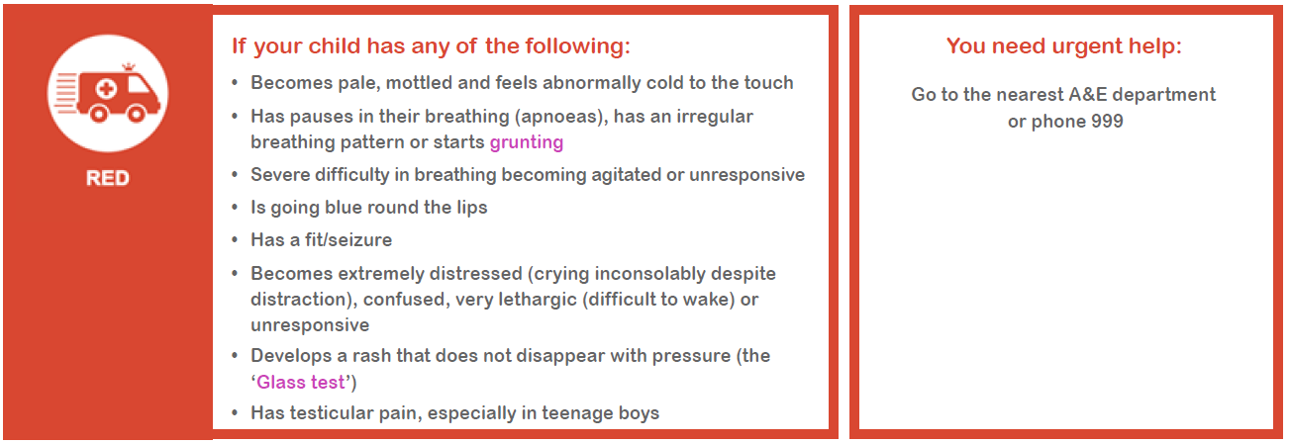
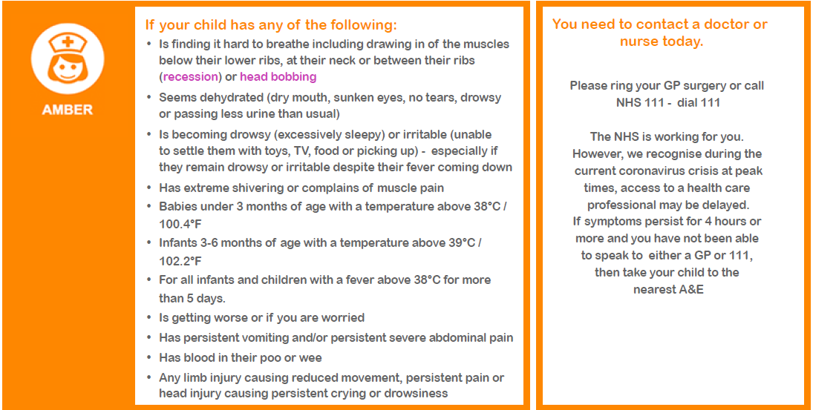
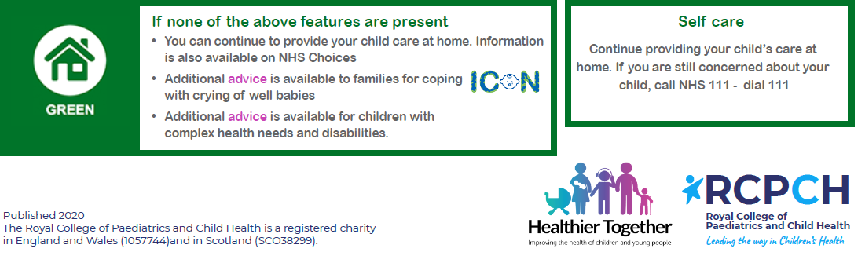

- Helping families with younger children cope with ‘social isolation and distancing’

For those of you with younger children in the household, we are aware how difficult it can be to get across the messages and explain what it means to be in ‘lockdown’ and to both socially isolate and distance from others. We hope you may find the following free resources useful to help your younger children follow the current restrictions in place.

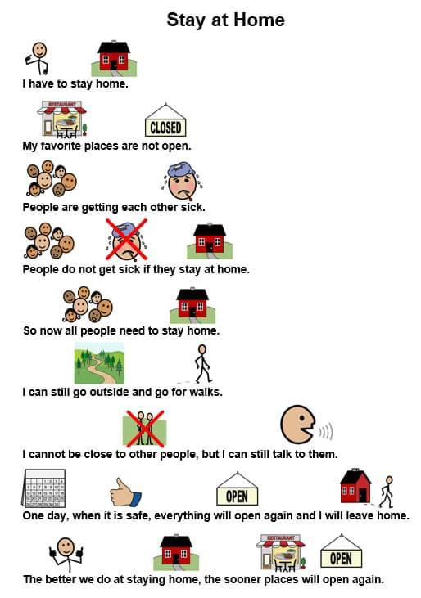

Also, checkout the free children’s book on Coronavirus, illustrated by Axel Scheffler, famed for the award winning ‘The Gruffalo.’: https://axelscheffler.com/books-for-older-children/coronavirus

- Helping families with older children cope with ‘social isolation and distancing’

For most children, try to develop and implement a new routine that all family members can follow. This will provides a balance of several different activities and appropriate interactions with others. At times like these, it can be easy to fall into unhealthy patterns of behaviour, which can make you feel worse.

Simple things you can do to stay mentally and physically active during this time include:

- Wake up relatively early – (annoying but it does help). Lying in bed until early afternoon will drain your energy levels and crush productivity. Set a nice alarm to wake up to and allow yourself more time to get ready and start the day properly.
- Stay connected to your friends and family via Skype, e-mail, video-calling and telephone / texting. Don’t rely just on texting though, as an audio-visual catch up is much more rewarding.
- Social media can be an excellent way to keep in touch with your friends and family. However, you should be mindful of your use of social media. Use it to promote positive interactions, and put your device away if it starts to negatively affect your mood. Many smartphones allow you to set time limits for certain apps such as Facebook or Instagram.
- It is important to maintain, where possible, some sort of daily routine. You should vary what you put into your routine to keep things different and interesting but try and include key elements consistently.
- Make a to-do list (or schedule / rota) with reasonable and specific things included. Finalise your schedule / rota the night before so you are ready and prepared for the day ahead. Include spending time doing things you enjoy as well as things you need to do.
  - Time to eat (breakfast, lunch and dinner)
  - Time to network chat and socialise, social media / gaming (IT based)
  - Time to do work, study, homework, coursework, learn, research
  - Time for exercise
  - Time for relaxing, personal downtime (non IT based)
  - Time to spend with family
  - Time to spend doing something fun / different / activity based
- Try to eat healthy, well-balanced meals, drink enough water, and try to avoid smoking, alcohol and recreational drugs
- If needing to socially isolate, spend time with the windows open to let in fresh air, arranging space to sit with a nice view if possible and get some natural sunlight. Get out into the garden or sit on your doorstep if you can, keeping a distance of at least 2 metres from others.
- If you don't need to isolate, you should try and get out of the house to do your daily exercise (walk, jog, run or bike-ride), keeping your social distance to at least 2 metres when outside.
- Look to introduce fun activities for you and the family
  - Themed meals
  - Special movie / Netflix nights
  - Quizzes and competitions
  - Kitchen dancing / Karaoke
  - Skype/FT friends other family to involve them too
- Getting a good night’s sleep is crucial for feeling emotionally healthy the next day. We all feel better after a good night’s sleep.

- Helping families with emotional and physical well-being

Having to be in ‘lockdown’, socially isolate and distance yourself (and your family) from your colleagues, friends and family members will make many of us feel stressed and anxious. These are truly extra-ordinary times where information and issues are changing extremely rapidly. It is not surprising that each day can feel totally different to the next and this is unsettling. What’s happening in the world right now can feel daunting, unable to make plans even for the immediate future - it’s very normal to feel worried and unsure about things.

We want you to look after yourself and your family during these difficult times. The following resources can help you and your family with your emotional and physical well-being.

Websites offering emotional well-being and support

- Childline (Free confidential help and advice for any Under 18 year old, whatever the worry)
https://www.childline.org.uk/
Call 0800 1111
- ICON (Babies cry: You can cope. Advice and support for parents coping with a crying baby)
http://iconcope.org/
- MIND (Mental Health Support with specific advice on ‘Coronavirus and your wellbeing’
https://www.mind.org.uk

- NSPCC Helpline (Worried about a child, unsure? Contact professional counsellors for help, advice and support)
Call 0808 800 5000
- Samaritans (Resources and help for all ages)
https://www.samaritans.org/
Call 116 123
- Young Minds (Supports children, young people, parents & carers with their mental health and well-being)
https://youngminds.org.uk

Websites offering advice on keeping fit, physical well-being

- Free 30 day Yoga course
https://www.youtube.com/watch?v=--jhKVdZOJM
- Herts sports partnership (workout from home)
https://sportinherts.org.uk/workoutfromhome/
- The Football Association (Staying fit at home)
http://www.thefa.com/get-involved/footballs-staying-home
- 21 best home exercises for men (workout from home)
https://www.menshealth.com/uk/building-muscle/a754099/the-15-best-beginners-exercises-to-do-at-home/

Domestic abuse – help and support for victims and perpetrators

Everyone should feel safe at home. For anyone who feels they are at risk of abuse, it is important to remember that there is help and support available to you, including police response, online support, helplines, refuges and other services.

If you or someone else is in immediate danger please call 999 and ask for the police. If you are not safe to speak – for mobiles use the Silent Solution system: call 999 then press 55 when prompted. If you can’t use a voice phone, register with the police text service - text REGISTER to 999. You will get a text which tells you what to do next. Do this when it is safe so you can text when you are in danger

Here are the details of local support services:

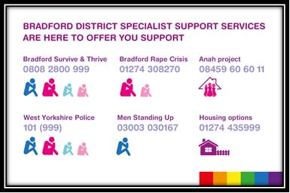

North Yorkshire Domestic Abuse Services: IDAS https://www.idas.org.uk/, 03000 110 110

Also available for advice & support are national services:

- The National Domestic Abuse helpline: Freephone 0808 2000 247 (24 hours a day) or online at https://www.nationaldahelpline.org.uk/
- Women’s Aid: online advice and support + live webchat https://www.womensaid.org.uk/
- Galop supports members of the LGBT+ community: Freephone 0800 999 5428 or email help@galop.org.uk.
- Male victims of domestic abuse: Freephone 0808 8010327 or online https://mensadviceline.org.uk/
- If you are hurting the one’s you love & want support & advice or you want help for your partner contact Respect: Freephone 0808 8024040 or online at https://respectphoneline.org.uk/

Anyone can be a victim of domestic abuse, regardless of gender, age, ethnicity, socio-economic status, sexuality or background.

GP practices are still here to help. Please telephone or submit an e-consultation via our practice website.

