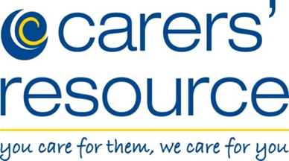
PODCAST

Join our podcast to receive a weekly WhatsApp message

Messages promote self care, wellbeing and bring you some informative news on a weekly basis

For more information contact: 01274 449660

